Good Kid MAAD City – A Transmedia User Experience

Tagline

‘If a flower bloomed in a dark room, would you trust it?’

Back Story and Context

The original narrative for this experience is from rapper ‘Kendrick Lamar’s’ studio album titled ‘Good Kid, M.A.A.D City’. This is a concept album, so we decided to use the existing narrative to create a transmedia experience for fans to get involved and enjoy. The narrative begins by introducing the characters; Kendrick meets Sherane at a house party before getting involved with gang-related crimes and committing anti-social behaviour. Following this Kendrick gets jumped for being in an area he is not from, which leads to a retaliation from Kendrick’s gang. Whilst contemplating the morality of a gang lifestyle, the retaliation results in the death of Kendrick’s friends brother, Dave. This is the final straw for Kendrick as he is reminiscing about past decisions and choices before deciding to leave the gang lifestyle behind.

Synopsis

Following the journey of Kendrick Lamar and his ‘gang’ through the common experiences of a gang-related lifestyle in Compton. The main narrative follows Lamar’s experiences with a rival gang, as well as with his partner Sherane. The main antagonist in the story is the rival gang, we never find out about these characters in detail. The main conflict in the story is a rivalry between two gangs. This leads to several incidents that result in members of both side being injured or killed. We also look at the effects this has on Kendrick and his relationship with Sherane.

The first inciting incident in the story involves the main protagonists committing a house burglary, from which a police chase ensues. The midpoint in the story would be when Kendrick is attacked by a rival gang for being from another neighbourhood. This leads to a retaliation, which is what the main story is built around. The climax is a shootout between the two, after which Kendrick decides the gang life is no longer for him, and chooses to leave it behind and pursue music.

Characters

- Kendrick Lamar - Kendrick is the main protagonist in the story which follows him through his childhood. He is a good kid who is caught up in a gang-related lifestyle in Compton, with music seeming like the only way out. He is in a relationship with Sherane and due to his gang ties with the Bloods, has an on-going rivalry with the Crips.

- Sherane Splinter - This is Kendrick’s girlfriend, after meeting at a house party they develop a strong relationship although it is not a smooth ride. This relationship is an escape from the drugs, guns and violence that surrounds them in Compton.

- Dave Hollis Jr – Kendrick Lamar’s friend who avoid involvement with the gang lifestyle and crimes that are being committed.

- Jermaine Hollis Jr – Dave’s brother, who is involved with the Crips, who are the opposition of Kendrick’s gang.

- The Bloods – The gang who Kendrick associates himself with and has underlying codes and rules that the members abide by. They associate themselves with the colour red.

- The Crips – The main antagonist in the story and opposition of the Bloods, who have an on-going street rivalry which usually results in violence and murder. They associate themselves with the colour blue.

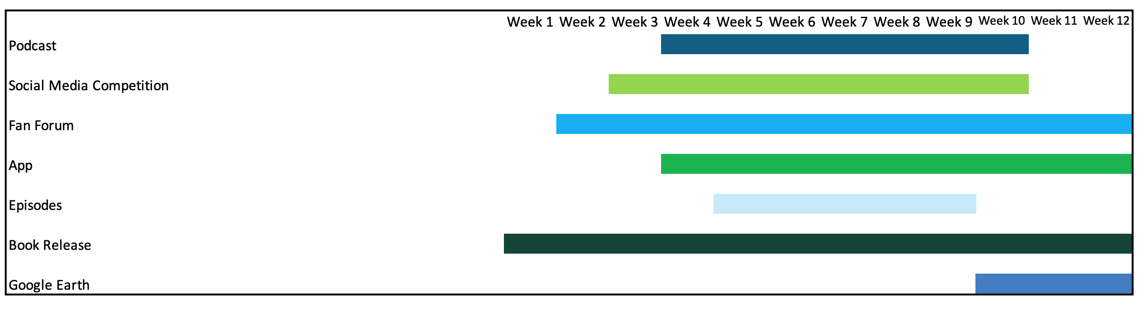
Timeline for Experience

Podcast (Week 4-10) – This will launch one week before the series on Netflix. First episode will introduce the story and increase anticipation and hype. Following this an episode will air every week discussing the story and plot up until one week after the series.

Social Media Campaign (Week 3-10) – This is a 7 week campaign intended to get fans involved and promote the upcoming series. A competition will be posted on Twitter, Facebook, Instagram etc. This will be an opportunity to design the official thumbnail for the TV series on Netflix and win other bonuses.

Fan Forum (Week 2-12) - This is a website for fans to discuss, share and compare any information or experiences. This is a chance to meet new people with similar interests and express your view. Kendrick Lamar will also be posting on this page and holding Q&A’s to get involved with fans.

App (Week 4-12) - This will include backstories and additional information for all the characters who are mentioned on the album and will appear on the TV Series. This is an opportunity for the audience to have an in-depth understanding of the characters thus adding an extra layer of depth to the story.

Episodes (Week 5-9) - The first episode of the TV Series will be released on Netflix on week 4, with each episode releasing on a weekly basis for the following four weeks.

Book Release (Week 1-12) - An autobiography of Kendrick Lamar’s life will be released on week 1. This will allow users to fill in missing gaps from the stories and have a greater understanding of the whole experience.

Google Earth (Week 10-12) - This will allow users to explore the locations that are featured on the album, book and TV Series.

User-Experience
Wk 1
Wk 2
Wk 3
Wk 5
Wk 4
Wk 6
Wk 8
Wk 7
Wk 9
Wk 10
Wk 11
Book Release – User reads book to build understanding of world and characters.
Fan Forum Launch – User interacts with other fans to build up knowledge
Social Media launch – User enters competition to win prizes
User listens to podcast
Episodes Launch and run through to week 9, user continues to engage with other features such as app, social media and podcast
Social media markets app, user downloads and gains more info on story
Google earth walkthrough released; user manages to increase knowledge base for story
End of story.

Social Media Campaign Proposal

Proposal

Social media presents an opportunity to promote the transmedia story to our target audience and connect with them on a personal level. However in order to do this it is important to build a following which we will achieve through giveaways and competitions across multiple platforms. The intention is to get fans involved in the transmedia experience and allow them to experience the journey in more depth.

Statistics for Kendrick Lamar’s social media accounts:

- 9,247,407 followers on Instagram (1st April 2019) , 5,542 average daily followers
- 11,627,027 followers on Twitter (1st April 2019) , increasing an average of
40,00 followers per 2 weeks since December 2018
- 8,759,089 fans on Facebook, lost 65,000 followers since October 2018
- 7,082,091 subscribers on YouTube (1st April 2019), averaging 2,211 daily subscribers

Based on the statistics and sources presented above Kendrick Lamar’s social media accounts are increasing in impressions with little media activity and fan engagement, with the anomaly of Facebook which is decreasing. An increase in media uploads and fan engagement is an opportunity to rapidly increase activity and stop fans decreasing. Based on these statistics, our campaign will be focused on Twitter and Instagram for the transmedia experience, as these are highest in activity. Each social media platform is utilised for different purposes so from a business/marketing perspective it is important to utilise this. Adapting to the different specifications of each app is key in order to achieve a successful campaign. This is contributing to the transmedia experience as it is promoting the narrative on multiple platforms to a wider audience. It is presenting an opportunity for fans to interact with the narrative and develop a greater understanding. Our social media accounts intend to remain active across the campaign. We will consistently engage with fans by answering questions, making light-hearted jokes and teasing upcoming content. These are common trends from organisations that are successful on social media and have a high follower count. Below is presented the advantages of each platform and how we intend to utilise them:

Instagram:
- Suitable for high quality pictures and photography.
- Based on this we are going to launch a hashtag campaign titled ‘#MAADcity’. Anything that is posted on this platform from the team and artist will feature this hashtag, to keep fans informed and give them an insight to behind the scenes to create a personal relationship.
- A giveaway that involves fans following the account and tagging their friends in the comments will be launched to increase activity on the account.
- We are launching a competition on Instagram in which fans have to post a photograph on their page recreating the Good Kid M.A.A.D City album cover. The post must feature ‘#MAADcityComp’ in the caption and the winner will be posted on our page and receive merchandise and a signed album as a prize. Best runners up will also be posted on our page to get more people involved.

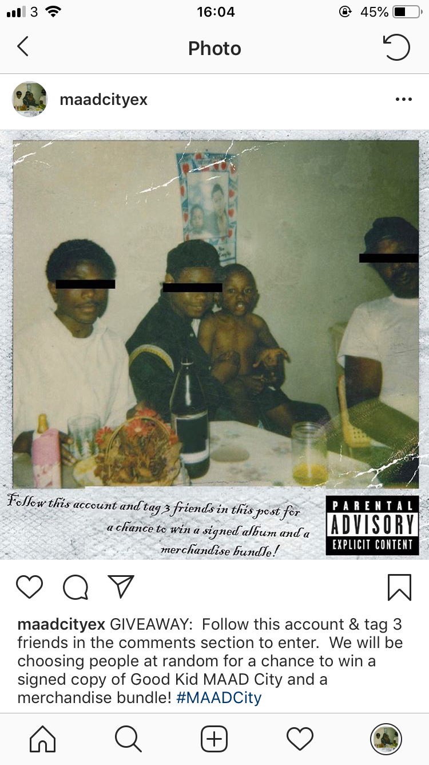

Twitter:
- Short, informative information.
- Giveaways will be launched on Twitter, these will involve people reposting and tagging their friends in the post in order to build a following and raise awareness.
- Launching competition for Kendrick Lamar’s fan to draw a thumbnail for the series to be used on Netflix. All of the fans submissions will be uploaded on a website and the winner is voted by the fans. The submission that receives the most post will be used for the official show when it is released.

Snapchat:
- Good for reaching out to a younger demographic.
- Branded filters – Good Kid MAAD City Face filters will be released near the launch of the series as a form of promotion.
- Behind the scenes – Artists, actors and anyone involved in the journey can post behind the scenes footage to increase anticipation.
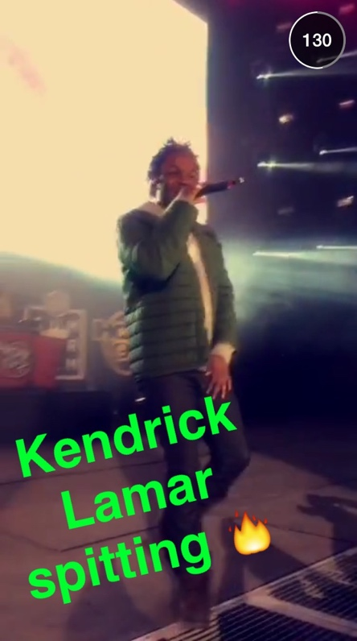

.
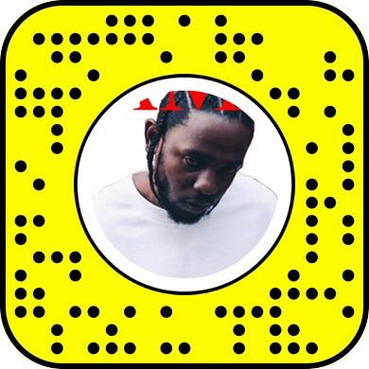

Facebook

Facebook:
- Live streaming and longer form video.
- Facebook is going to be used to launch the trailer for the Good Kid MAAD City trailer.
- A giveaway will be hosted, involving reposting and tagging friends in a post in order to build a following on the page before posting the trailer.

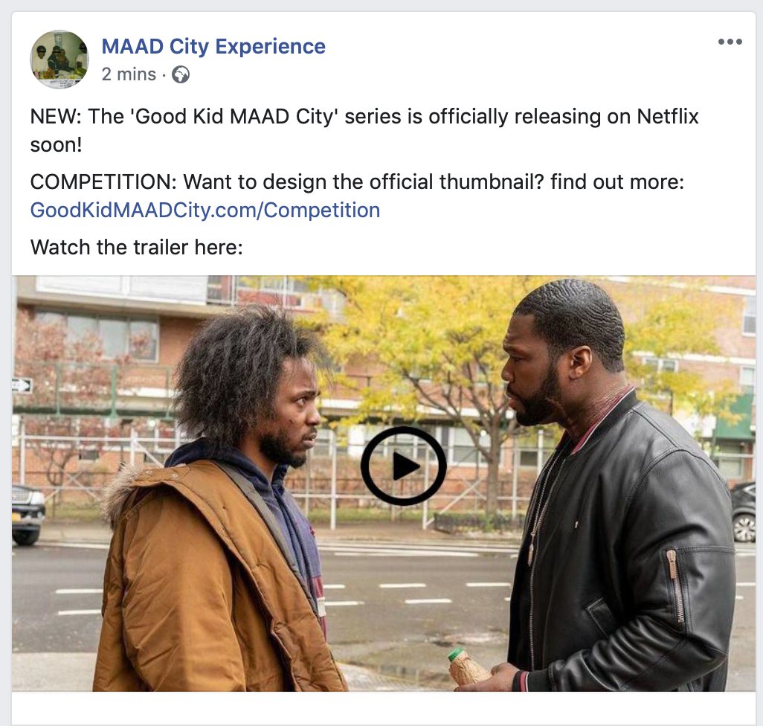
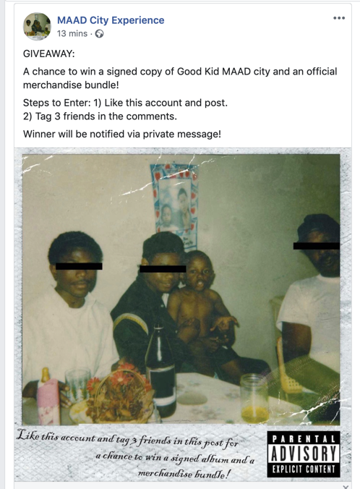

We have proposed a timeline for the social media campaign below with the aim to promote the upcoming release of the Good Kid MAAD city series and interact with fans:
Week 1:
A giveaway will be posted on Instagram, Facebook and Twitter in order to raise awareness of the transmedia experience and increase follower count.
Week 2:
Instagram competition will be released to get fans involved.

Official Trailer of the series will be launched on Facebook.
Week 3:
Winners from week 1 giveaways will be announced.

Twitter competition will be released to get fans involved.

Week 4:
Branded filters released on Snapchat.

Various posts across all social media platforms teasing the release of the upcoming series.
Week 5-8:
The series will be launched on Netflix.

Social media activity and interaction with fans will remain active.
\

Bibliography

BusinessGov (2019) Benefits of social media for business [Internet] https://www.business.gov.au/marketing/social-media/benefits-of-social-media [Accessed 11th May 2019]
Social Blade (2019) Instagram statistics [Internet] https://socialblade.com/instagram/user/kendricklamar [Accessed 9th May 2019]
Social Bakers (2019) Social Media Statistics [Internet] https://www.socialbakers.com/statistics/twitter/profiles/detail/23561980-kendricklamar [Accessed 9th May 2019]
Social Bakers (2019) Facebook statistics [Internet] https://www.socialbakers.com/statistics/facebook/pages/detail/241273033091-kendrick-lamar [Accessed 9th May 2019]
Social Blade (2019) YouTube Statistics [Internet] https://socialblade.com/youtube/user/kendricklamarvevo [Accessed 9th May 2019]

