What’s it worth? Developing equivalent assessment opportunities for students with disabilities, through the use of digital video and audio recordings
This project was extended to allow for further development and investigation into multi-format coursework. Read the extended project report.

Pauline McInnes, Bridget Middlemas and Phil Cheeseman, Roehampton University

The project team were awarded audio and video recorders and associated equipment. They aimed to contribute to some new assessment guidelines for academic staff on the assessment of multi-format coursework, which is a particular issue for students with disabilities. At the moment, there is little formal or workable guidance in this area, which causes concern for both staff and students. They were particularly keen to consider ways in which e-coursework (such as e-portfolios or wikis) can be fairly assessed by academic staff.
The team planned to draft their own institutional guidelines as a result of our project, and will also be making them available for national discussion via the SEDA and M-25 JISCmail lists. We feel that these guidelines will be of interest to all academic staff wishing to adopt a more inclusive approach to assessment, which will benefit a wide range of students, not just those with a disability.
The team set up a small working party of 6 undergraduate students with a range of disabilities, and worked closely with academic staff to ensure that the multi-format coursework is an equivalent piece of work to the rest of the cohort’s (e.g. If the student wishes to replace a 3000 word essay with a DVD documentary or radio interview, how long and how detailed should this be? To what extent will technical competence be assessed, if at all? Have the tutors been fully consulted, and will they accept the revised format?)
Students were all second or third years, and studying one of these programmes:
- Classical civilisation
- Psychology
- Sociology

Significant Developments
Prior to this project, the team had not fully envisaged the need to liaise with outside bodies (e.g. the British Psychological Society, the TDA and the British Association of Social Work) .These issues became very pertinent as the final guidelines were written.
An additional outcome of the project has been to provide good advice and resources for staff and students on using video and audio recording techniques for assignments, in terms of how to present coursework which incorporates DVD, digital or audio materials. The team have been working closely with colleagues from film studies and photography to put together some clear and simple advice for non-specialists, which includes:
- planning an structuring your recordings using a story-board
- issues relating to lighting and sound quality
- where to access support
- giving access to others for assessment / marking
- examples of good practice from other disciplinary areas (they are in the process of setting up some resources in Moodle at the time of writing)

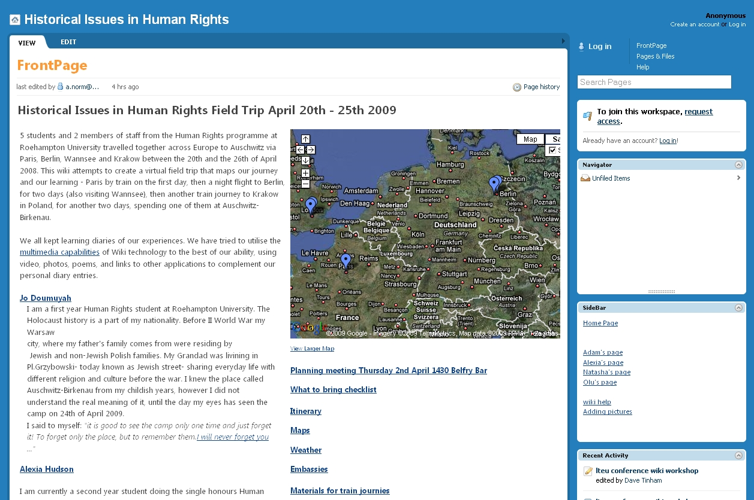
In Autumn 2009, the team will be providing some staff training workshops in the area of multi-format assessments, to encourage them to try out this approach with small groups of students.
The team have filmed student interviews to provide useful staff training materials.
The project has already extended beyond its original brief, as colleagues and other students from around the campus have discussed our progress. One interesting example is that the team were able to fund a group of Historical issues in human rights students, who undertook a field trip to Auschwitz and Berlin, and built their own wiki of the trip. This innovative piece of multi-format coursework incorporated video, audio and digital photos, as well as text.
View the wiki.
Figure 1 - Screenshot of the wiki produced by a group of Human Rights students
The students and staff involved in the group wiki project have now agreed to work with the team to consider multi-format assessment issues such as:
- Whether such a piece of work might be able to replace the traditional 3,500 word essay for a 20 credit undergraduate module
- How to fairly assess a collaborative group wiki.
- Support requirements for non-technically minded students.
- How to set ( or not set) the boundaries for such work, for example one student wrote a superb poem about her experiences at Auschwitz, although this was not part of the original plan. She then included it in her section of the wiki. We are therefore thinking about suggesting that multi-format coursework has both formal sections ( to evidence programme learning outcomes) and “ free choice” sections to encourage and permit a wider range of contributions.
- How to organise a presentation day when students can showcase their projects ( this would make assessment much more straightforward for the staff involved).

Benefits of this approach for inclusion
This project has enabled staff to stand back from traditional academic practice, and take a fresh view of what is understood by the term “ assessment”. It has enabled the team to involve staff and students in a very real way, and given them a platform to suggest adaptations and changes to current programme design and delivery.
Colleagues from SEDA ( the Staff and Educational Development Association) have also taken a great interest in this project, and the team have benefitted from their suggestions.
Additionally:
- Our 6 students are very motivated and enthusiastic about the “ What’s it Worth?” project, in spite of the fact that they have found it very hard at times.
- Learning support and disability staff have welcomed clear guidance around the area of assessing non-traditional coursework.
- There has been a very good response from SEDA JISCmail colleagues, who all report that these guidelines could be usefully adapted elsewhere.
- Academic staff involved have all shown a keen interest, and are now contributing to discussions around programme design / revalidation etc.
- The project is having a direct impact on our new Learning, Teaching and Assessment Strategy for 2009-2012, and is enabling us to make some clear recommendations about good, inclusive practice.
- The University's Students’ Union are now becoming more involved in the “student voice” approach to curriculum and programme design.

One of the main benefits for the institution is that they now have a clearly informed view on the potential advantages of encouraging staff to adopt a more inclusive approach to assessment, as they also have some very positive comments from participants on the issue.
Some representative quotations from participants:
"It’s fantastic to take learning into the 21st century, and encompass all learner types, because aural and visual learners have had it their way for too long I say! Let the kinaesthetic learners show their true colours..."
- Student with learning difficulties and a long term mental health condition
"I think your project will really show everyone what can be achieved, and hopefully, encourage others to think about offering visual assignments alongside text-based ones."
- Dyslexia Tutor to one of the participants
"This sounds a potentially very interesting alternative form of assessment and I’m very interested in hearing more about it. A more diverse assessment portfolio will mean that some of our students will really be able to show what they’re capable of…"
- SENDA Coordinator, School of Arts

How this approach was developed and embedded
The team will be running some staff training workshops on inclusive assessment and multi-format coursework during 2009-2010.
The findings of the report will be incorporated into the university’s Assessment Policy, and Assessment Guidelines for Academic Staff.
The team ran a workshop at SEDA’s May 2009 Conference ( Brighton, Sussex) in order to gather the views of a range of academic staff from learning and teaching in HE backgrounds. Details can be found at
The project team's paper from the SEDA conference

Drawbacks and disadvantages
What’s it Worth has been a very complex and time-consuming project, but the team are extremely pleased to note that changes are already starting to happen. The project has enabled them to approach academic staff from a range of disciplines to discuss inclusive assessment, and encouraged them to present their ideas to colleagues from other institutions. For example, Bridget Middlemas presented a workshop at Leeds Metropolitan University’s Listening to the Student Voice Conference in May 2009.
One of the main drawbacks has been arranging suitable times to meet up with students, and ensuring that they are able to keep “on task” and complete their assignments in good time. The student group have all struggled previously with coursework deadlines, but this did not deter the team from working with them to consider new ways of evidencing their learning.
Another drawback is that these new forms of assessment are much more multi-faceted in terms of the students’ need to work with staff from around the campus – e.g. the e-learning team, media services, library staff and learning support staff. Some students are not used to working with so many different people, although they have all said that they are pleased to have participated. This has made the team seriously consider possible implications for the way that the induction process is organised and are aware that from autumn 2009, support may need to be offered to new students support in a different and more inclusive way.

Summary and reflection
The team believes that this has been a very worthwhile project which will be of direct benefit to students from a diverse range of backgrounds, particularly students with disabilities and those from widening participation backgrounds.
One of the main advantages has been that staff from support units have been able to discuss assessment issues with a range of staff and students, and learn from each other in terms of planning the next stages.
This still requires a great deal of discussion and consultation (with students, staff and colleagues at other institutions) before it is “rolled out” more formally. The team are now at the stage of meeting formally with our Academic Registrar and our Assistant Deans for Learning and Teaching, in order to embed some recommendations at programme level.
Having trialled the idea of multi-format coursework with a small sample of undergraduate students, we now need to consider the assessment implications of our suggestions for:
- Staff who have to mark this type of coursework , in terms of their time, their technical skills, and their understanding of what we mean by “equivalency”.
- The balance between formative and summative assessments.
- The balance between peer assessed and tutor assessed coursework.
- The role of support staff (e.g. laboratory or technical staff) who may be working alongside students to complete their assignments.
- Training and awareness raising needed for learning support colleagues.
- The role of external examiners in the marking process.
- Ensuring that all outside bodies are in agreement with our suggestions for equivalency.
- Supporting academic staff to review their current practice in terms of ensuring that inclusive assessment options are available to all those students who require this way of being assessed.
- Sharing good practice with other institutions.

Some funding has been committed to further supporting this work, which will then be disseminated in 2010.
These are suggestions – you will need to discuss in fine detail with your programme team it is Draft Guidance and JISC TechDis are currently working with the project team at Roehampton University to refine and develop this guidance for wider usage across the sector.
It is Draft Guidance and JISC TechDis are currently working with the project team at Roehampton University

Text-based coursework | OR Live presentation / viva | OR E-portfolio /multimedia coursework/ WIKI | OR Group work
Essay – 3000 words, plus 10-15 references | A2 or A3 Poster , using text and/or artwork/visual data, plus 10 minute presentation to rest of group; with accompanying 500 word explanatory / background text.  You will need to use 10-15 references. | E- Project 2000 words, plus 1000 word equivalent to include photographs, charts, visual resources, DVD clips, artwork etc, plus 10-15 references | 30 minute teaching session for a group of six peers. Make your own handouts / resources / games to illustrate your session. You will need to use 10-15 references.
100% graded by lecturer, and double marked where appropriate | 50% Peer assessed by group  50% graded by lecturer | 50% Peer assessed by group  50% graded by lecturer | 50% Peer assessed by group  50% graded by lecturer  OR  100% peer assessed

Text-based coursework | OR Live presentation / viva | OR E-portfolio /multimedia coursework | OR Group work
Essay - 5000 words, plus 15-20 references | A1 or A2 Poster , using text and/or artwork/visual data, plus 15 minute presentation to rest of group; with accompanying 1000 word explanatory / background text | DVD - produce a 10-12 minute edited and titled DVD, with accompanying 1000 word explanatory / background text . You will need to use 15-20 references. | 45 minute teaching session for a group of ten peers. Make your own handouts / resources / games to illustrate your session. You will need to use 15-20 references.
100% graded by lecturer, and double marked where appropriate | 50% Peer assessed by group  50% graded by lecturer | 50% Peer assessed by group  50% graded by lecturer  OR  100% peer assessed | 50% Peer assessed by group  50% graded by lecturer  OR  100% peer assessed
Research report – 10,000 words  with 25-30 references. | Research report – 5,000 words plus 30 minute presentation to group, plus accompanying A4 750 word handout |  | DVD project: make a 15-20 minute DVD, edited and titled, to show to the rest of the group. Plus 2000 word accompanying handout with 25-30 references.
100% graded by lecturer, and double marked where appropriate |  |  | 50% Peer assessed by group  50% graded by lecturer
Patchwork text exercise: construct 400 words each week for 6-8 weeks, and hand in final piece of work as a 5,000 word project. Discuss each section with your peers, and use their feedback for your final piece of writing. | Presentation – 20 minute PowerPoint presentation to students from your group, giving 6 examples of theories / research that you have studied. Handouts to be provided, with 10-15 references. | E- Presentation – produce a 10-12 minute presentation, with recorded commentary, giving 6 examples of theories / research that you have studied. Supporting text and 10-15 references to be included. | Workshop – devise and run a 30 minute workshop for your group, introducing 6 examples of theories / research that you have studied. Handouts to be provided, with 10-15 references.
50% Peer assessed by group  50% graded by lecturer | 100% peer assessed ( clear assessment guidelines to be provided by lecturer) | 50% Peer assessed by group  50% graded by lecturer | 100% peer assessed (clear assessment guidelines to be provided by lecturer)

Text-based coursework | OR Live presentation/ viva | OR E-portfolio / multimedia  coursework | OR Group work
Reflective diary – 5000 words, based on 5 hours of experience (e.g. work placement; field trips; museum/ gallery visits etc) including reference to theory and good practice | Wall of photos: create a “wall of photos” on an A1 or A0 whiteboard / flipchart ( full instructions to be provided) to share your experiences with selected group members and your course tutor. Make notes about each photo, and make an audio recording of your 15 minute talk. | E- photos: create a “wall of photos” ( full instructions to be provided) to share your experiences with selected group members and your course tutor. Each photo to have accompanying audio file, with reflections. | Dialogue sheet – 4-5 students to create a dialogue sheet on a large piece of A2 or A1 paper, to provide the basis for a group discussion. Choose 2 reflections from each person’s own notes ( on a range of topics / feelings) and share these with your peers.
100% graded by lecturer, and double marked where appropriate | 50% Peer assessed by group  50% graded by lecturer | 50% Peer assessed by group  50% graded by lecturer | 100% peer assessed (clear assessment guidelines to be provided by lecturer)
Laboratory / studio / field work report 5000 words
Multiple choice paper: 30 questions , one hour paper |  | Multiple choice paper: 30 questions , one hour paper  on StudyZone
100% graded by lecturer, and double marked where appropriate |  | Marked automatically
Seminar contribution: | Presentation – 20 minute PowerPoint presentation to students from your group, giving 6 examples of theories / research that you have studied. Handouts to be provided, with 10-15 references. | StudyZone activity: | Group seminar contribution:
 | 100% peer assessed ( clear assessment guidelines to be provided by lecturer)

Suggestions received so far:
It is a good idea to allow students a choice of formats over the course of their programmes, rather than only offering text-based assignments such as essays or traditional reports.
Ensure that the programme learning outcomes are being met, whatever the format of the assessments.
Presentations of non-traditional coursework can be run concurrently with larger groups, to make better use of time. Lecturers can move between presentations if appropriate, or ask a colleague to provide additional marking support for the session.
It’s a good idea to set up a presentation day for viewing a WIKI or DVD, and all such presentations will need to be filmed, in case of grade queries (e.g. from the external examiner). Each student can then keep any such recordings on a DVD, or on their e-portfolio if they have one.
Make sure that you leave time between student presentations / vivas for grading / comments / feedback etc.
A multimedia presentation can also be a web document which provides equivalent content. ( Agree as a course team what you will accept as equivalent, or ask the LTEU for further advice.)
In all cases, we recommend that students sign a cover sheet attesting to the assignment’s / paper’s authenticity upon submission
Make sure that you clearly describe the purpose / aims of the assignment, and your own and expectations / marking criteria. Whatever the format you choose, you will still need to be evidencing the original programme learning outcomes.
Fonts should be Arial or Times New Roman, and in size 12 for any text based documents.
You will need to be very clear about hand-in / completion dates for all assignments, irrespective of which media the assignment is being submitted in. Ensure that the students allow sufficient time for copying their completed work onto DVD or CD if required.
In the case of illness before or during a presentation, or failure to complete work on time, you will need to be clear to the students about your hand-in policy
Issues to consider for DVD production:
- Titling / cover sheet / authoring
- Project planning / time management for the student
- Basic information included ( name, date, assignment title etc)
- Quality of filming
- Timing / viewing speed of text & images
- Content & sectioning ( what do we do when there’s no paragraphs!)
- Support prior to and during hand-in
- Final grade & role of external examiner
- How to arrange a suitable viva opportunity
This project was presented at the Higher Education Academys Annual Conference 2009 - for a video of the presentation and other resources see HEAT at the Higher Education Academy Conference
This project forms part of a report on Hearing the Student Voice - see the report.

