Using RefWorks to create an annotated bibliography
Add records to your RefWorks account as you usually would.
Edit the record to which you wish to add annotations by clicking on the title and then the pencil icon on the right of the screen.
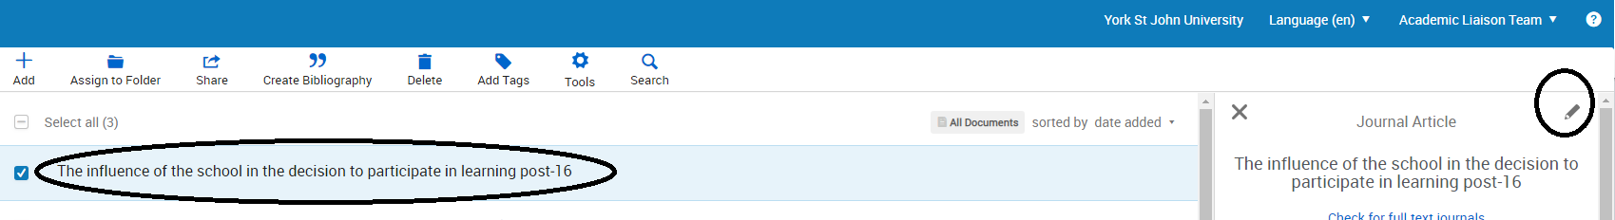
Enter your annotation in the notes field in the record details.
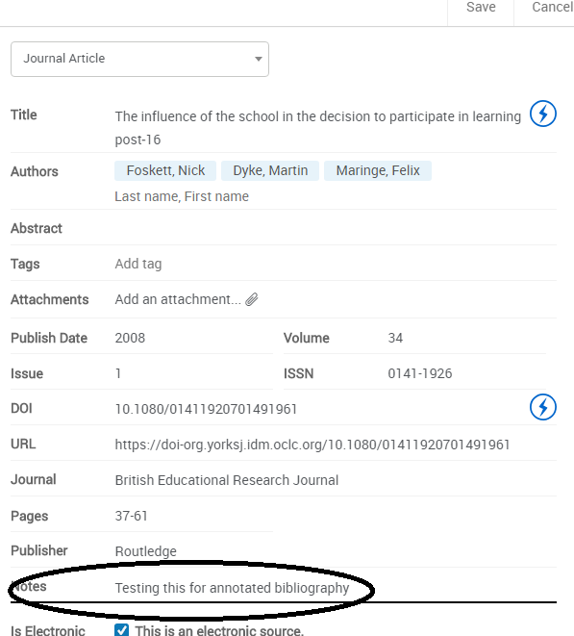
Ensure you save the record before exiting.
Once you have added annotations to all of the records you need, click ‘Create bibliography’ and choose ‘York St John Harvard with annotations’ as your style.
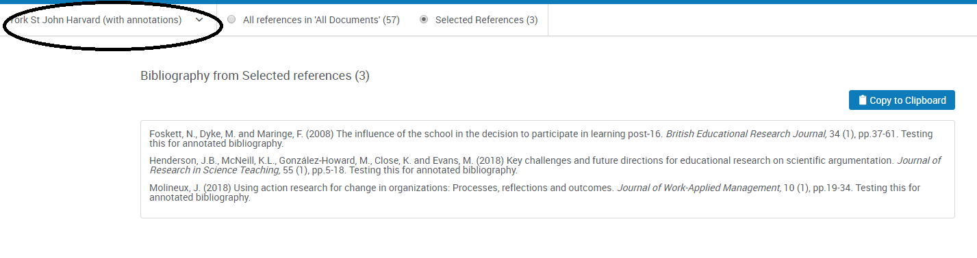
Click ‘Copy to Clipboard’ and then paste into your own document in Word or equivalent. You can then edit the text as you wish.

