Podcast 불고기 Recipe
Imagine that you attended a Korean festival at York St John University. There were many booths to introduce Korean culture and you participated in one booth that introduces cooking Korean foods. You will post a short podcast about the Korean cooking class as a project in your Korean module. In your post, you will introduce which booth you participated and the불고기 recipe. Also, you will describe how you felt about the event. Use the following structure for the pod cast and introduce the 불고기 recipe below.
[Pod cast]
- Greeting
- Talk about your experience at the Korean festival.
(Use ______________ -아/어 봤어요.)
- Tell them what you are going to introduce during the pod cast.
(Use ______________ -으/려고 해요. e.g., I am going to introduce…)
- Introduce 불고기 recipe.
(Use ______________ -주세요 and -으/려고 해요 e.g., Please prepare XYZ. I am going to make 불고기sauce.)
- Tell them how you felt at the Korean festival.
- Closing
[Recipe]
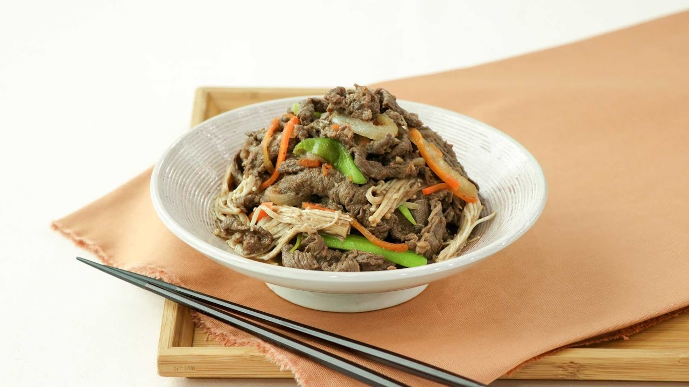
- Prepare thinly-sliced (thin) beef
- Make 불고기 sauce. Mix soy sauce, sugar, water, sesame oil and minced garlic.
- Mix the sauce with the beef, scallion, and onion.
- Wait for an hour.
- Roast it.
[Useful words]

양념 sauce
간장 soy sauce
설탕 sugar
물 water
참기름sesame sauce
파 scallion
양파 onion
마늘garlic
얇다 thin
소고기 beef
불고기 레시피 recipe
요리 dish
소개하다to introduce
준비하다 to prepare
요리하다 to cook
만들다 to make
다지다 to mince
섞다 to mix
기다리다 to wait
1시간 one hour
굽다 roast
맛있다 delicious
재미있다 fun

Task of the week: Living on or off campus
[Scenario] Imagine that student A and student B are planning to go to Korea for study abroad. You two have to decide whether to live on or off campus. You are discussing two options with your partner. Student A has collected information about living on campus, whereas Student B has collected information about living off campus. Exchange the information about each option and compare the two options for each category given in the tables. At the end of the conversation, you will decide where to live.

[Useful words and expressions]

기숙사 dormitory
원룸 studio
관리비 utility fees
풀옵션 furnished
들다 to cost
한달에 per month
식사 meal
통금 시간 curfew
부엌 kitchen
걸어서 by walk
수업 class
셔틀버스 shuttle bus
시내 city center
룸메이트 roommate
한 방 one room
학교 school
근처 nearby
포함 included
10만원 정도 about 10만원
대중교통 public transportation
이용 가능하다 available
시끄럽다 noisy
동네 neighbourhood
월세 monthly rent
보증금 deposit
만원 10,000 Won
천원 1,000 Won

Step 1 [Planning: individual work] The table shows information about living on campus and off campus. Read the table and think about which option you would prefer and why.

Student A

Living on campus
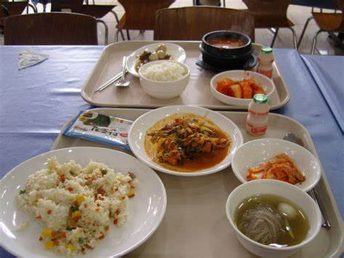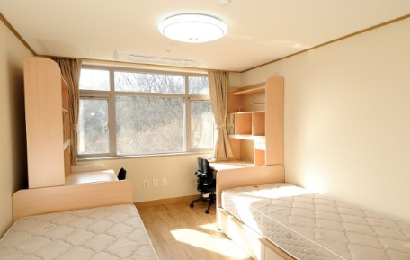
Where | 기숙사
Cost | It costs 30만원 or 45만원 per month  Utility fees are included  A meal costs 4천원at cafeteria
Features | 11pm curfew  No kitchen  10 minutes walking to class  Shuttle bus to city center  Living with a roommate
Options | 1) 2 people in a single room (45만원 per month) vs.  2) 4 people in a single room (30 만원 per month)

Student B

Living off campus
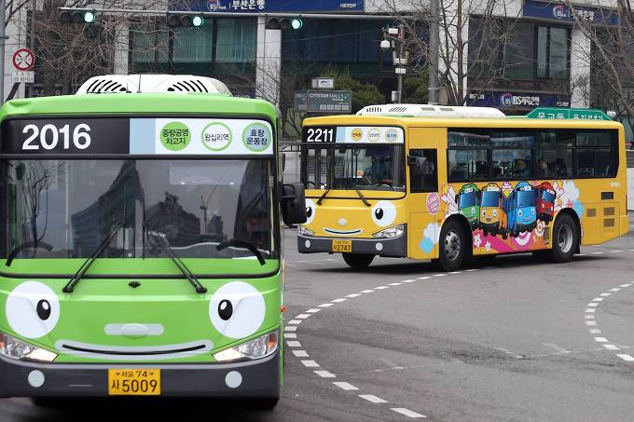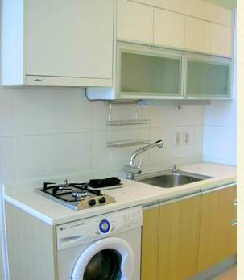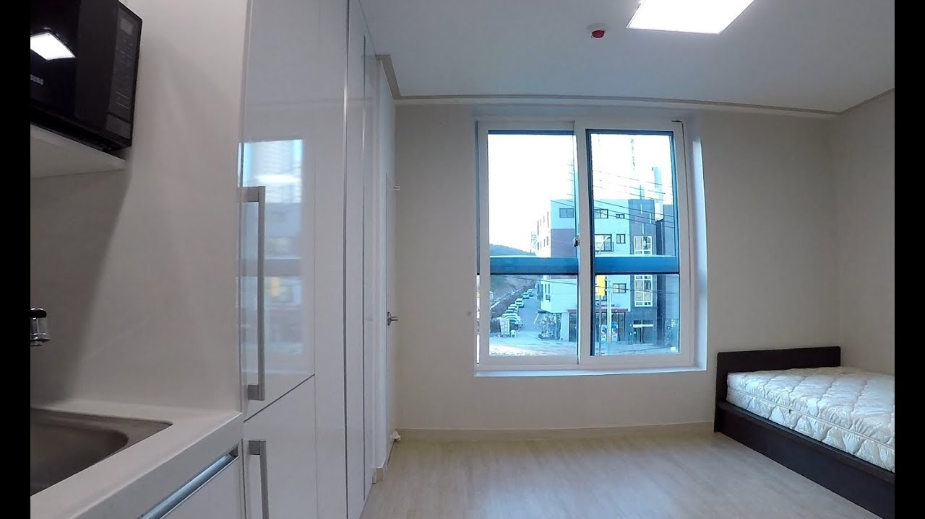
Where | 학교 근처 원룸
How much | 60만원 or 70 만원 per month  Utility fees are NOT included.  Utility costs about 10 만원
Features | Kitchen included  30 minutes to campus  Public transportation available  Furnished  Noisy neighborhood
Options | 1) Deposit 500 만원 + monthly rent 60만원 vs.  2) No deposit + monthly rent 70 만원

Step 2 [Decision making: Online chatting with peer]
Exchange the information about each option. You MUST compare the two options explicitly. Then, decide where you and your partner are going to live during study abroad. Discuss why you want to live there, what options you consider and why. Try to use the target grammar feature –(보다) 더 (comparative). Try to use different modes (pictures, videos, sentences), and you MUST send at least five voice messages/notes to your partner during the chat.

Your preferred choice:
Where you want to live
Why you want to live
Which option to choose and why
Step 3 [Reporting: one-to-one speaking with the instructor via Microsoft Teams]
You are going to meet the study abroad advisor at York St John. You will discuss your preference on housing with her, include the following information:
- Greeting
- Introduce yourself
- Let her know of your preference and explain why.
- Compare your preference with the other option using the following structure:
(_______ 이/가) _______ -(보다) 더 ______.
- Closing

[Screenshot of online chatting with peer]

[full conversation]
JM: [voice recording] 안녕 괜찮아요?

JR: [voice recording] 안녕 제니씨 네 잘지냈어요?

JM: 네에, 😁 아 조씨- 어디 살고 싶어요??

JR: 대학교 기숙사에 살고 싶어요!

JM: [voice recording] 와 좋은 생각이야

JR: 젠니씨 어디 살고 싶어요?

JM: 학교 근처 원룸에 살고싶어요!

JR: [voice recording]왜 학교 근처 원룸이 살고 싶어요?
ㅏㅏ~ 원룸 한달에 얼마예요?
JM: 월세는 육십만원에서 칠십만원 사이에요...
비싸!! 😥
JR: 정말!? 네 너무 비싸!
[voice recording] 기숙사가 학교 근처 원룸보다 더 싸요.

JM: [voice recording]아 그렇구나
기숙사에 얼마예요??

JR: 기숙사가 한달에 삼십만원이나 사십오만원 들어요.

JM: 아, 좋은 가격 이에요! 💰

JR: [voice recording] 삼십만원 기숙사가 제일 싸요.

JM: 좋아요!

JR: 관리비는 포함되어요?

JM: 관리비는 포함안됬어요 😬
관리비는 만원 정도 들어요 🔌💡

JR: 진짜?! 그거 너무 비싸요!

JM: 조씨, 관리비는 포함이에요?

JR: 네 관리비는 포함되어요

JM: 와 ~ 나는 질투네요 😭😭🤧

JR: 학교 근처 원룸에 부엌이 있어요?

JM: 네! 부엌이 있어요! 풀옵션 이에요 🛋🛏🚿

JR: 좋아요!

JM: 기숙사방을 같이써요??

JR: 네. 하명이나 세명 룸메이트와 살거예요

JM: 아 ~ 괜찮아요!
JM: 방을 안같이써요
JR: 아 그래 좋아요.

JM: [voice recording] 사진 있어요?
JM: 📸📸

JR:
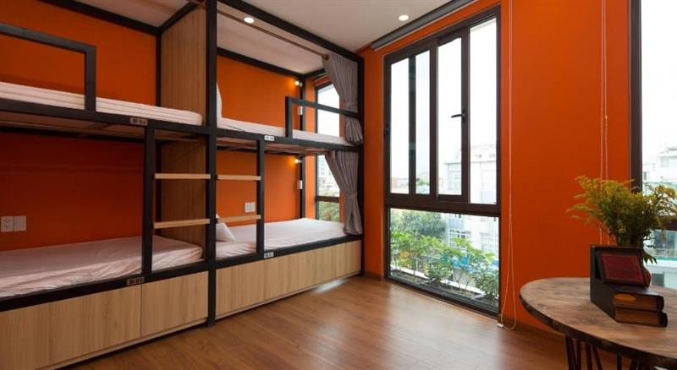

너무 좋아!!

JM: 😍😍 와
이것은 내꺼야!
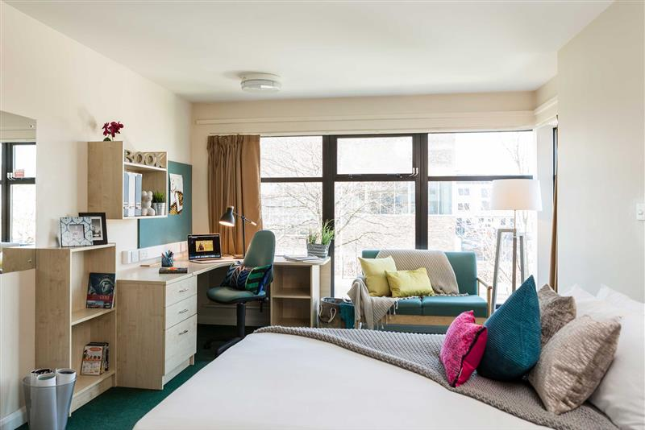

JR: 🤩🤩 대박!!

JM: 어떻게 생각해? 어디에서 같이 살고싶어요???

JR: 미안해요. 저는 기숙사가 제일 좋아해요. 😅😓

JM: 오엠지! 나도 😆

JR: 정말? 대박!
어떤께 좋아요? 삼십만원이나 사십오만원? 🧐

JM: 4 명는 너무 많아요. 45만원이 좋아!

JR: 😯 동의해요

JM: 4 명는 너무 많아요 하지만 2 명은 괜찮아요!

JR: 괜찮아!

JM: 🎊🎊 같이 하자!
안녕 조

Online lecture stream on comparative grammar -보다 더

