Undergraduate research conference
The conference took place on 28th October 2016 from 10:00-15:30, case study presentations, discussion groups and workshops were in various rooms in the De Grey building. The poster exhibition was located in DG foyer as were refreshment breaks and lunch. The room bookings and catering were done through the Conference and Events team, all other aspects of the conference were organised by ADD.
The conference was promoted through a variety of platforms. Current student researchers were emailed and encourage to submit proposals. Social media was also used to encourage bookings and promote the event.
All bookings were taken through Eventbrite as well as the majority of communication emails to delegates. A reminder email was sent to delegates 2 days before the event. Multiple emails were sent to presenters via the ADD mailbox regarding registering for the event, room requirements for the day and printing requests.
Out of the 39 delegates registered 19 registered at the start of the day. Some delegates attended for only part of the day and so did not register the start of the conference. Delegates were mainly undergraduate students; however 6 members of academic and support staff also attend the day.
The evaluation form was completed on paper at the end of the conference, this way a prize winner could be drawn on the day. 10 delegates completed the evaluation form meaning the response rate was 47%. A breakdown of responses can be found below.

Q1 – what did you expect to gain from the conference?
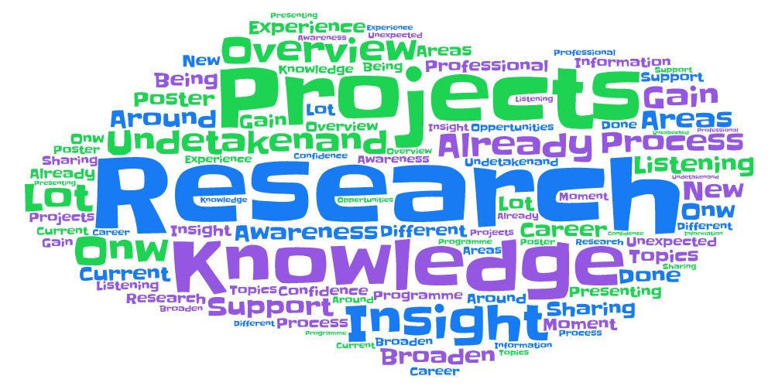
The majority of delegates said they wanted the opportunity to gain insights into research projects at the university and learn about the research going outside of their own project or area.

Q2 - How would you rate the following aspects of the day – Pre-event Communication?

Recommendation – Continue to use Eventbrite for bookings and delegate communication but send out a reminder email approximately 1 week before the event including a programme.

Q3 - How would you rate the following aspects of the day – Location?

Recommendation –By having different sessions scheduled in different rooms it provides more opportunities for delegates to skip sessions and only attend part of the day. A solution would be to liaise with the conference and event team earlier with potential dates. Book rooms with a capacity of 30 or more and if possible book fewer rooms for a longer period of time.

Q4 - How would you rate the following aspects of the day – Organisation of the day?

Recommendation – continue to organise the event as in previous years, feedback forms did not suggest any changes need to be made for future conferences.

Q5 – Which session was the most useful / interesting?
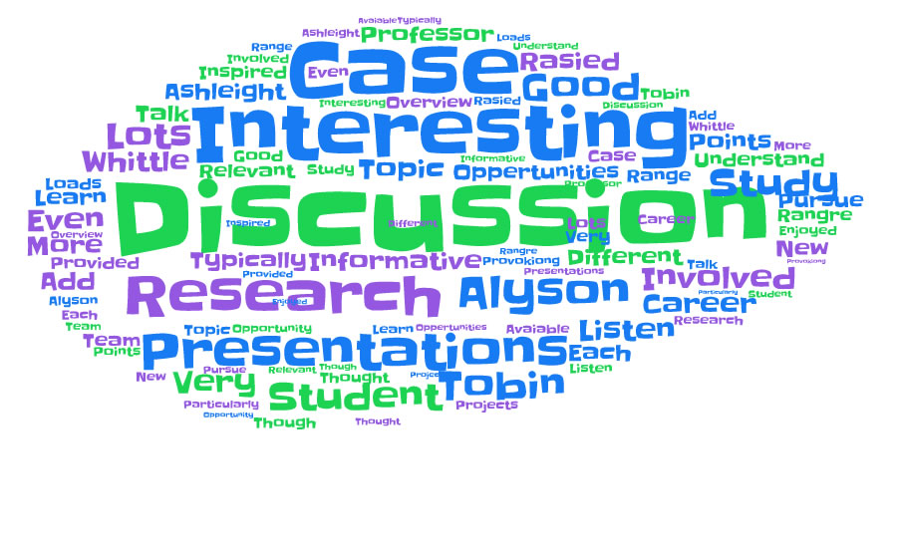
Most delegates found the research discussion session with ADD team members and a form Student researcher the most useful session. Delegates said that this raised a lot of interesting discussion points and encouraged them to seek more research opportunities. Delegates also enjoyed the keynote and said the discussions after the case study presentations were beneficial.

Recommendation – continue to include the discussion session as part of the day as well as including the discussion aspect at the end of each case study presentation. Include a ‘Students as Researchers discussion session’ where staff members can promote their projects to student and answer any clarification questions. This would be another opportunity to promote the projects as well as demonstrating the range of research opportunities available to students.

Q6 – What session was the least useful / interesting?
The majority of delegates either did not answer this question or answered ‘none’. Any delegate who gave a particular session justified their answer by pointing out this was probably because it is not an area they are particularly familiar with.
Recommendation – Continue to promote the event as an opportunity for any undergraduate research to be presented and encourage delegates to think of the conference as a university wide conference. Also encourage delegates to give any feedback about particular presentation styles (i.e. talking to fast) during the arranged practice session before the conference rather than after on evaluation sheets.

Q7- How would you rate the following aspects of the day – keynote speaker?

Q8 - How would you rate the following aspects of the day – Discussion session?

Q9- How would you rate the following aspects of the day – Networking Opportunities?

Recommendations – this question was the lowest scoring on the feedback form, this could possibly be solved by increasing the lunch time break. Another solution would be to have a dedicated networking session rather than just including this in the lunch break, staff working on research projects could be invited to attend the session and discuss their projects with students. This could tie into a previous recommendation of a ‘Students as Researcher session’

Q10 – What did you like most about the conference?
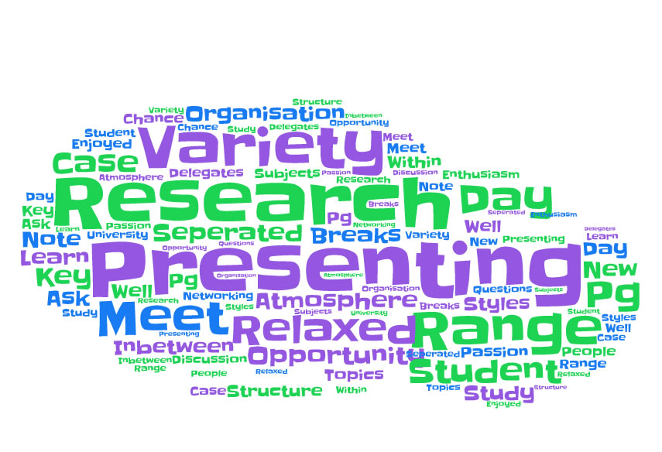
Delegates appreciated the relaxed environment of the conference as they said it gave them more confidence when presenting as well when asking other presenters questions. They all commented on the wide variety of research projects happening at the university and that this stopped then day becoming boring.

Q11 – What aspects of the conference could be improved?
All delegates expressed that they would have liked more time during the lunch break to view poster exhibitions. The location of the conference was mentioned as some sessions were in slightly crowded rooms. Delegates also mentioned that that conference should be advertised more widely using platforms other than twitter as this may have led to a larger audience throughout the day.
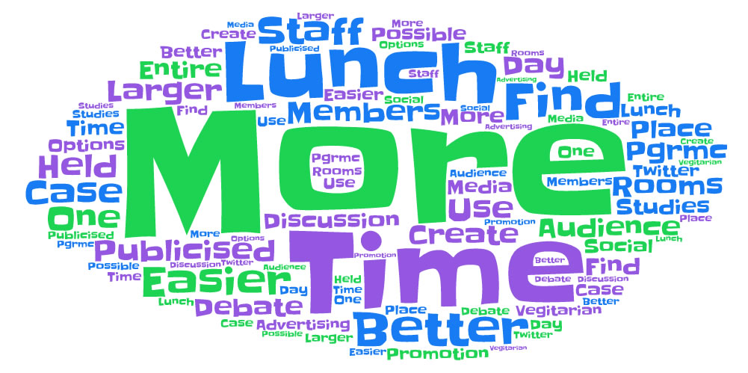

Recommendation- extend the lunch break

Q12 – Has this event changed the way you think about your study or future career?
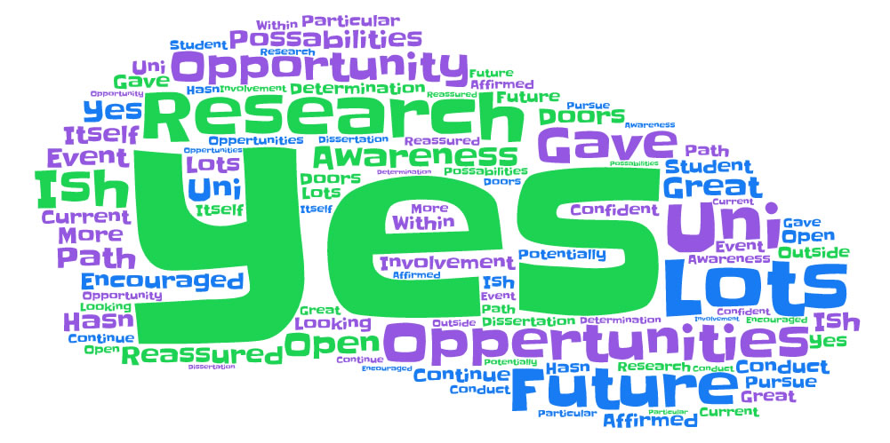

Q13 – Do you have any other comments regarding the event?
