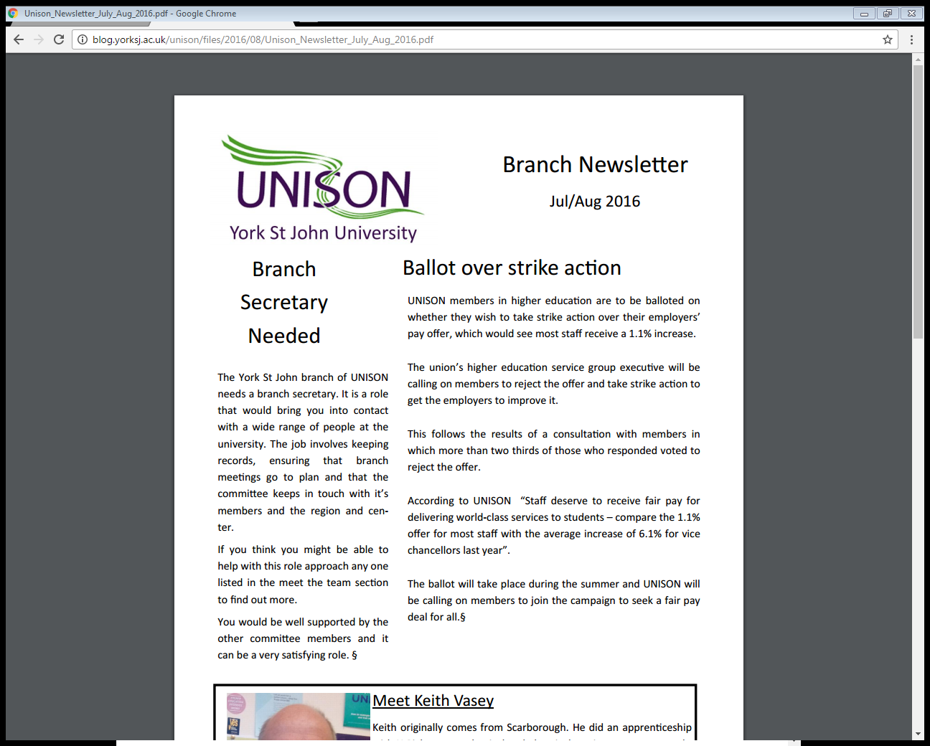

Branch Newsletter

July 2017

**Your Union**

Last year a branch member was the victim of a hit and run accident in which they were knocked off their bike on the way to work. The member sustained a serious knee injury and was off work for a number of weeks. Unison put them in touch with the solicitors who have now brought a case against the driver. Through Unison this member was helped to fill in all the claim forms including pay lost, as the member hadn’t been working at YSJ long and wasn’t entitled to claim full sick pay. The member was also helped by UNISON to claim expenses for hospital visits and doctors’ appointments.

**UNISON National Conference**

Last month Dave and Becky went down to Brighton for the National Conference. There were some really fantastic debates including UNISON announcing its support to smash the public sector pay cut and the £10 an hour minimum wage. The conference was closed by Jeremy Corbyn, long term UNISON supporter. Watch his full speech here; <https://www.youtube.com/watch?v=7ifYxuIAe7Y&feature=youtu.be>

Dave working and playing hard in his new hat!!

**Pay Explained**

You will remember last month we asked you to accept or reject the HE pay offer increase of 1.7%. UNISON’s higher education members have accepted an employers’ pay offer for 2017-18 worth between 1.7% and 2.4%, with higher increases for the lowest-paid staff.

The lowest pay point (spinal column point 2) will receive the highest increase, bringing it to the living wage rate of £8.45 an hour for those working a 35-hour week.

UNISON’s head of higher education, Donna Rowe-Merriman, commented: “Members working in universities have reluctantly accepted this year’s offer.

“Whilst higher than recent years, it still does not go far enough in compensating staff for successive years of low wage increases.

“The HE service group executive has already begun work on next year’s claim and will want to mobilise support from across HE to ensure decent pay for our members in future.”

Members voted by 71.1% to 28.9% to accept the offer in a consultation carried out by the union’s branches.

The employers were informed of the result after the service group executive ratified the consultation, which saw almost three-quarters of union branches (74.6%) return a response, and a majority vote for acceptance in every UNISON region.

Unions and employers also agreed to continue work on dealing with the gender pay gap and zero-hour contracts in the sector

**UNISON VICTORY**

UNISON Legal Services has been successful in its challenge to Employment Tribunal Fees.  Last week, the Supreme Court, the UK'S highest court, ruled that the Government acted unlawfully when it introduced fees to bring claims in the Employment Tribunals in England, Scotland and Wales. Since 2013, workers have had to pay as much as £1,200 plus to have claims for sex discrimination or unfair dismissal heard at Tribunal.

As the Supreme Court has said Employment Tribunals play a vital role in enforcing employment rights by employees and workers including the low paid. The Court found that UNISON's evidence showed that the fall in claims when fees came in was 'so sharp, so substantial and so sustained' that fees could not reasonably be afforded by those on low to middle incomes. It also held that fees particularly deterred claims of low value which as we know are generally brought by the most vulnerable workers.   
   
This historic judgement makes heavy criticism of the Government's actions. It found that the system of fees introduced in 2013 infringed constitutional rights. The Court said that citizens' right of access to the courts which is guaranteed by Magna Carta was effectively prevented by the Fees Order which introduced fees in Employment Tribunals. The level at which the fees had been set contravened 'elementary economics and plain common sense.’

UNISON’s next steps are to;

* call for the Government to quash the rules relating to fees,
* reimburse all fees paid since 2013,
* Pay UNISON's costs in full.
* immediately remove all references to fees on ET claim forms and government literature, websites and advice

Dates you don’t want to miss!

**Thursday 7th September**

**UNISON Stall**

Holgate

10:00-13:30pm

**Thursday 9th November**

**UNISON Stall**

Holgate

10:00-13:30pm

**Thursday 21st December**

**UNISON Christmas Party**

Student Union

**Monthly surgery dates coming soon!**

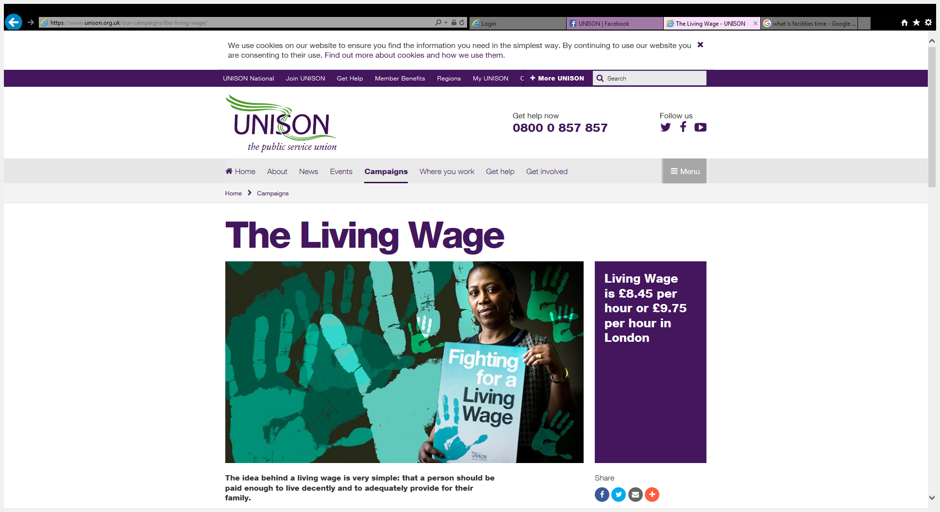

**How to Join**

There are three simple ways to join UNISON and get essential cover wherever you work;

1. Join securely online

2. Call 0800 171 2193

3. Return a paper form which you can access via contacting [unison@yorksj.ac.uk](mailto:unison@yorksj.ac.uk)

Keep up with national UNISON news, events and campaigns and member benefits