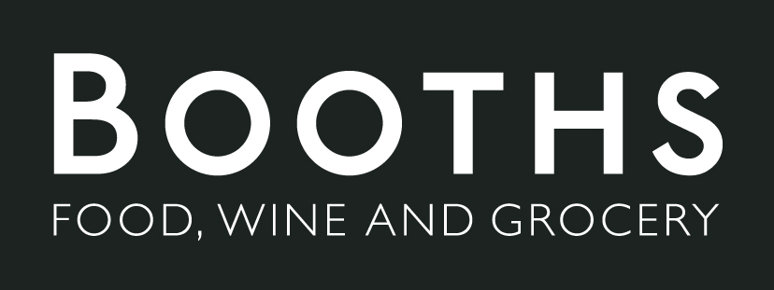

Online shopping app brief
The aim of this app is to broaden Booths’ clientele, the app will be easily accessible to the public and offers delivery right to their doorstep. We have investigated other shopping apps to address what our app needs and doesn’t need. | 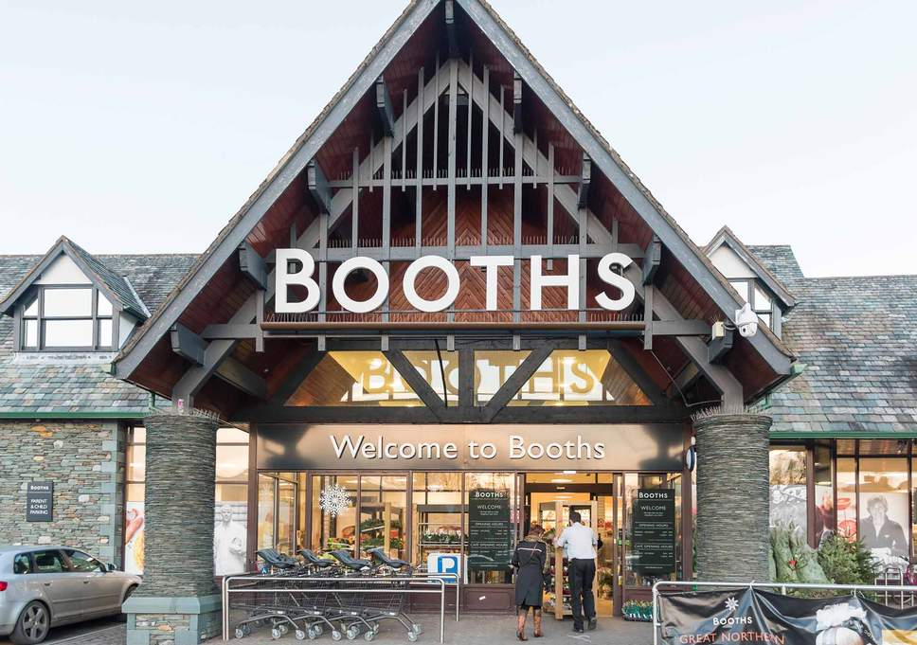
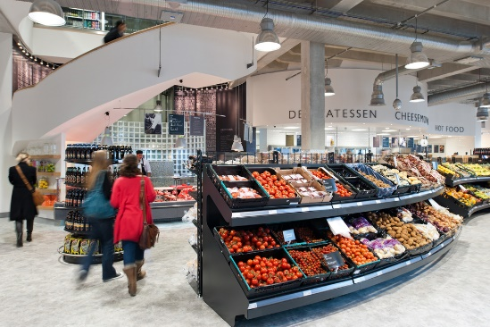 | This app aims to benefit Booths revenue, allow them to be more technologically advanced and most importantly meet customer expectations.
The target audience of this app is viewers from the North, aged 25+. Families and adults who don’t have a lot of time on their hands. The advert will show the audience how if they don’t have time to go from one supermarket to the other you can check what’s in stock in store beforehand. | 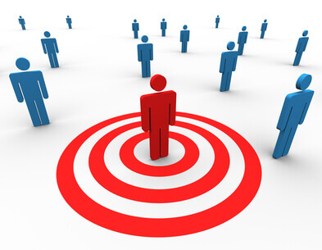
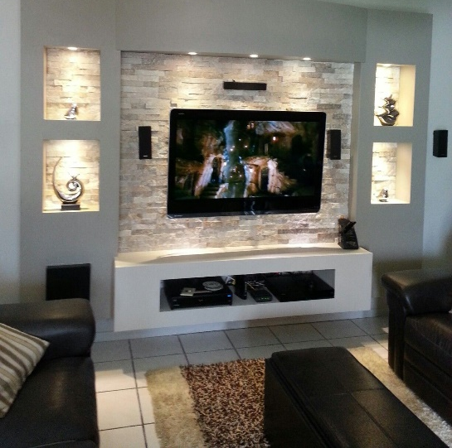 | Based on this the advert will be distributed on tv channels like ITV and Channel 4 around the northern area and will include visuals of the app’s features. We will aim for a dinner time slot for the advert as this is the time of day that most people are hungry. The luxurious foods shown through the apps features will appeal to the audience more at this time in the evening.
The video will be light hearted and friendly by showing happy customers using the app. This will also portray how easy to use the app is and how it will benefit you as a customer.

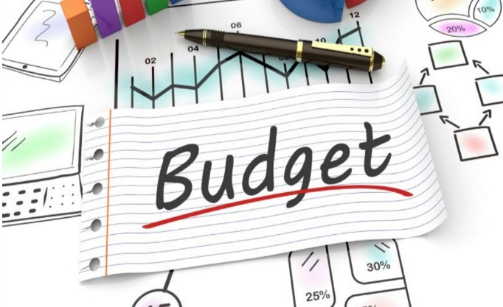 | The budget will be discussed in our first meeting together and we will allow three revisions after the first initial agreement on the prototype of the app

