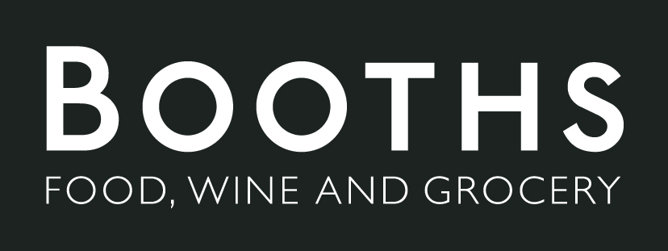

Social Media Advert Brief
We will create a short video that showcases booth high quality and locally sourced products to post on social media. The video will be similar in tone a Marks and Spencer’s food advert, the products will look very desirable. The products in the video will be food and drinks.

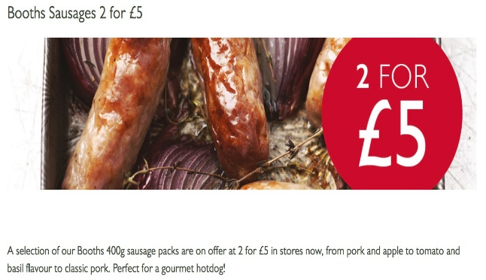 | Visuals in the video will show the high-quality food sold at Booths with close-up shots along with the reasonable prices.
The aim of the advert is to raise Booths online and social presence and spread the message that ‘You can get quality food products at Booths.’ This message would help raise brand reputation and increase customer interest. | 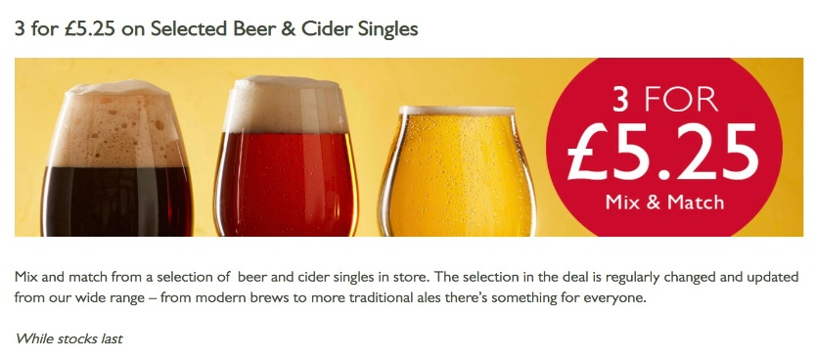
 | Our primary target audience for this advert are people aged between 30 and 70. This is quite a broad demographic of people, but booths’ products have a wide appeal; in general, everybody likes high quality food and products made locally.
The advert will be made to be posted on Facebook specifically, because a lot of Facebook users fit our demographic and you can also boost your posts though paid promotion towards certain ages ranges. We will also host a giveaway on Facebook alongside the advert, where people who share the post and tag a friend are given the chance to win a few products that were included in the ad. The video will also have subtitles so mobile viewers without sound playing will still be able to consume the advert.
 | The advert will also be posted on Twitter, Pinterest and Instagram because Booth does have a presence on those sites.
The client approval process will allow for three changes.

 | The advert can be shot in a relatively short amount of time since the production isn’t very complexed. The set will be simple, we don’t need any actors (only a voice actor for the voice over.)

