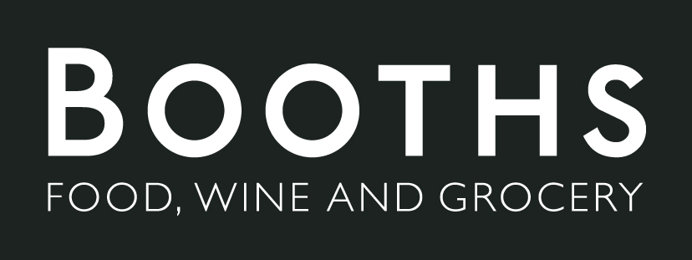

You shop we drop advert brief
We will produce a short video advert that displays how easy it is to use our you shop we drop service. The tone of the advert will be friendly and simple, it will show a scenario example of a customer using the service. | 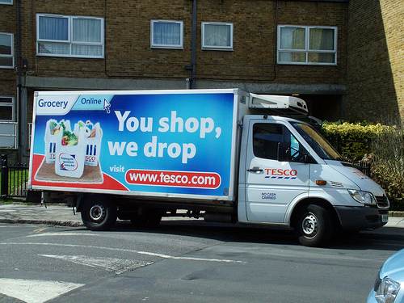
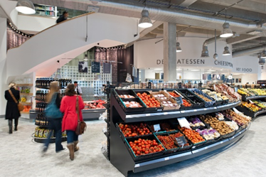 | The video will have shots of a store and customers interacting with the shop assistants. With text showing a simple set by set process of how to use this service.
The target audience for this app will mainly be aged 45+ and from the North. This is aimed for people who don’t drive so transport through buses/trains. Mainly the elderly will find this most useful as even if Booths is two doors down from their house they can’t always carry heavy shopping bags full of food.

The aim of this advert is to make people aware that booths now deliver, and this would help to expand the company to new customers and even give loyal customers another option.

 | The advert will be distributed on tv with programmers that allow local advertising which would be channel 4 and ITV. We would aim for prime-time television, around the news preferably as it attracts the same audience as booths does.
The new you shop we drop feature is a new avenue for the booths as it uses new ways of making the booths experience easier and more desirable because of this. This will hopefully create new possible customers.

The advert will demonstrate how easy the scan as you shop system is with customers looking happy wandering round the store scanning everything they want to buy. At the end of their experience they pay at the checkout and either enjoy some time in the café or head back out for the rest of their day.

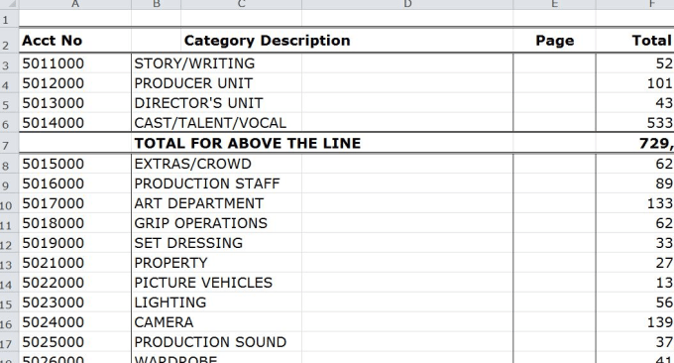 | The budget will be having to be agreed upon in our first meetings with the company depending on what they would be happy with. With then several meetings afterwards to check how the ad is coming along.

