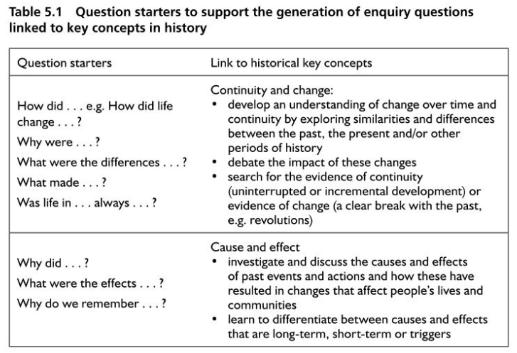
Enquiry Questions
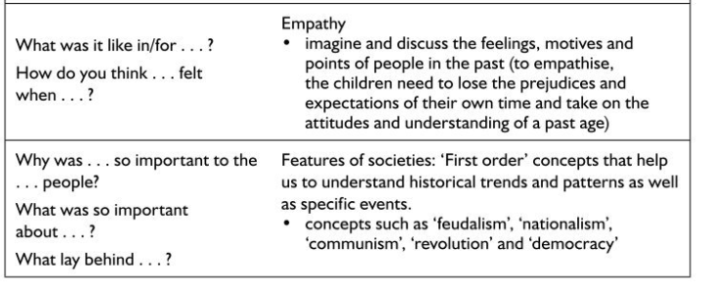
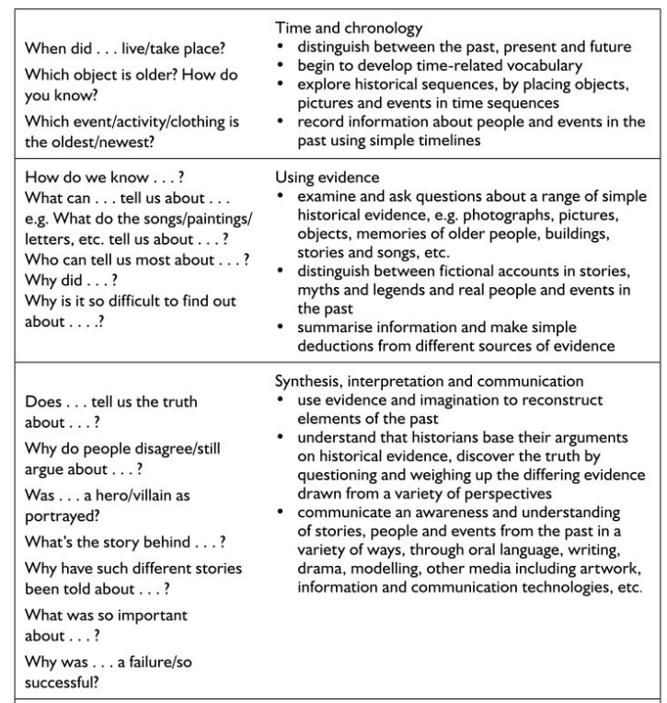Pickford, T., Garner, W., & Jackson, E. (2013). Primary humanities: Learning through enquiry. Los Angeles, Calif: SAGE.

The Enquiry Process

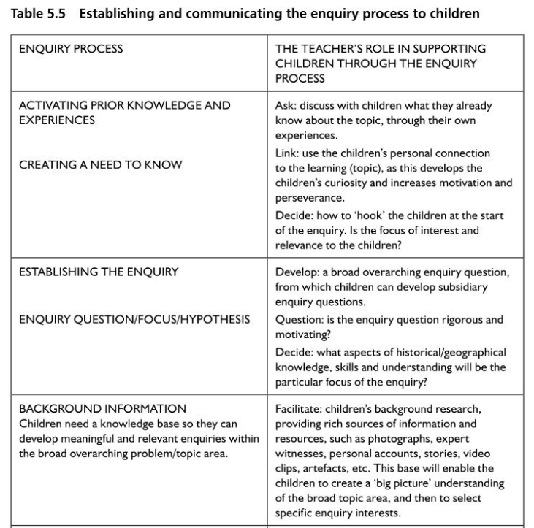
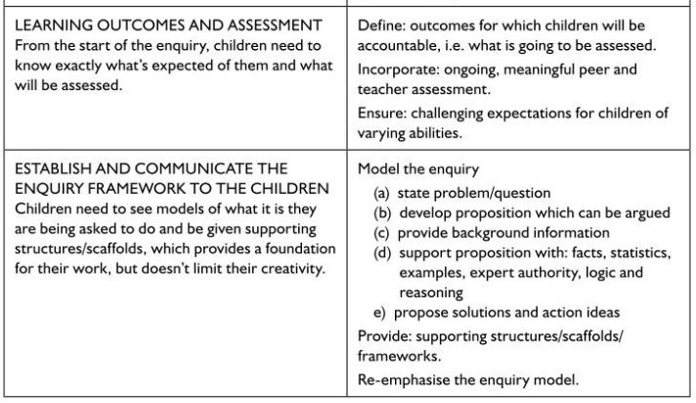
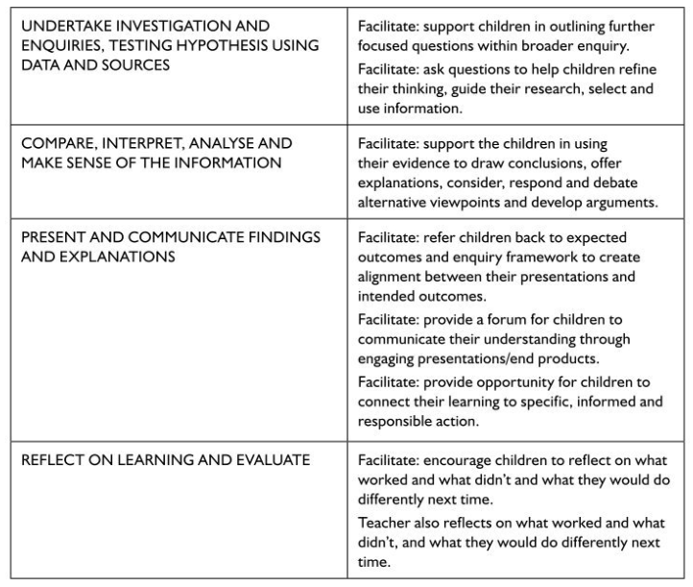Pickford, T., Garner, W., & Jackson, E. (2013). Primary humanities: Learning through enquiry. Los Angeles, Calif: SAGE.

