Feedback
Secondary NQT CPD Package

Resource Pack
To be completed alongside viewing the accompanying video.

Contents
Page | Activity | Start time on video | End time on video
3 | Introduction | 0.00 | 06.26
6 | Verbal Feedback | 06.26 | 13.44
9 | Written Feedback | 13.44 | 19.37
15 | Whole Class Feedback | 19.37 | 31.56
17 | Self and Peer Assessment | 31.56 | 42.42
19 | Reading List

Activity 1
Aims:
Watch the introduction section of the video (0-6m26s) and complete the following tasks.

What do you understand by feedback?

Feedback is….

Feedback is important because….

A definition:

Feedback is information given to the learner (by the teacher) or to the teacher (by the learner) about the learner’s performance relative to learning goals or outcomes. It should aim towards (and be capable of producing) improvement in students’ learning.
Feedback redirects or refocuses either the teacher’s or the learner’s actions to achieve a goal, by aligning effort and activity with an outcome. It can be about the output of the activity, the process of the activity, the student’s management of their learning or self-regulation or them as individuals (which tends to be the least effective). This feedback can be verbal or written or can be given through tests or via digital technology. It can come from a teacher or someone taking a teaching role, or from peers.

EEF (2016) Feedback. Available at: https://educationendowmentfoundation.org.uk/evidence-summaries/teaching-learning-toolkit/feedback/ (Accessed: 30/12/2020).

Annotate the diagram with the different ways you can provide feedback to students, the ways you receive feedback from students and the way students feedback to each other.

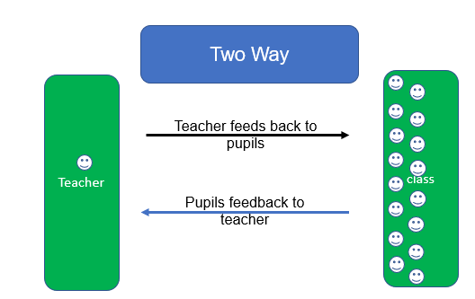

Find out what your school/department feedback policy is. Make any useful notes/things to remember here.

Activity 2
Aims:
Watch the verbal feedback section of the video (6m26s – 13m44s) and complete the following tasks.

What is Self-efficacy?

What questions do you ask in lessons? How could you improve them?

A definition:

- Self-efficacy – the level of confidence we have in ourselves to reach our goals. This can affect student answers to our questions, motivation, and effort.
- High Self efficacy – Optimistic about their performance, negative feedback spurs them on.
- Low self-efficacy – can react negatively to both positive and negative feedback – but can respond positively to ability or effort feedback – be careful!

Strategies
- Cold Calling
- No opt-out
- Say it again better
- Think, Pair, Share
- Whole class response
- Probing

Describe each strategy below.

Plan to use one or more strategies in your lessons and reflect on your practice.

Which strategy worked well?

Which could you adapt and make even better?

Activity 3
Aims:
Watch the written feedback section of the video (13m44s – 19m37s) and complete the following tasks.

Reflective Scenarios:
1 - A teacher realises that they haven’t looked at a set of books for 2 weeks.
The teacher diligently marks the books in time for the upcoming work scrutiny.

What is wrong with this?

What could they do better?

2 - Students complete work; the teacher gives students feedback the next lesson after scrutinising their books. The next lesson is a week away.

What is wrong with this?

What could they do better?

Read the EEF – A Marked Improvement (2016), Available at: EEF-MarkingReview-A4-AW.indd (educationendowmentfoundation.org.uk) (Accessed 30/12/2020)
At the end of each section there are discussion points. Answer these questions (copied below)

Grading
- What is the right balance of grades and comments in our marking?
- Do our pupils ignore formative comments if there is a grade on the page?
- Can we consider alternative ways of expressing pupils’ progress to them that avoids simple grades?
- How can we ensure that none of our students underestimate their potential and are aware of their current level of performance?

Corrections
1. How do we distinguish between mistakes and errors?
2. Does our marking approach require our pupils to work to remember or reach the correct answer?
3. What strategies can we use to ensure that our pupils’ underlying misunderstandings are addressed?

Thoroughness
1. Would marking time be more effective with less acknowledgement marking?
2. What would a marking approach look like based on ‘mark less, but mark better’?
3. What balance should we strike between marking for SPAG and marking for subject specific content?
4. Does our marking focus on the learning objectives related to the piece of work that has been completed?

Pupil responses
1. What are the best ways to provide the time for pupils to consider and respond to written comments?
2. How do we check that pupils understand all written comments and are purposefully engaging with them?
3. Are pupils given an opportunity to redraft or improve their work after receiving written feedback, or are our comments intended to improve future pieces of work?

Creating a dialogue
1. What is the most effective way to check that pupils understand our marking?
2. Have we attempted to assess the ‘time-effectiveness’ of dialogic or triple impact marking?
3. Are we clear about the purpose of responding to pupils’ responses to create a written dialogue?
4. To what extent do acknowledgement steps enhance pupil progress?

Targets
- Do we set specific targets that can be immediately acted upon?
- Do pupils understand the targets we set them?
- Are there occasions when we could use coded targets to reduce workload?

Frequency and speed.
1. What is the right balance between speed versus quality in our approach to marking?
2. How should our decisions about the speed or frequency of marking affect the type of marking that takes place?
3. How do we balance the speed with which marking is completed against the speed with which pupils are able to act on the feedback they receive?
4. What role can verbal feedback play in giving quick, precise and frequent feedback?

Activity 4
Aims:
Watch the whole class feedback section of the video (19m37s – 31m56s) and complete the following tasks.

Template for whole class feedback
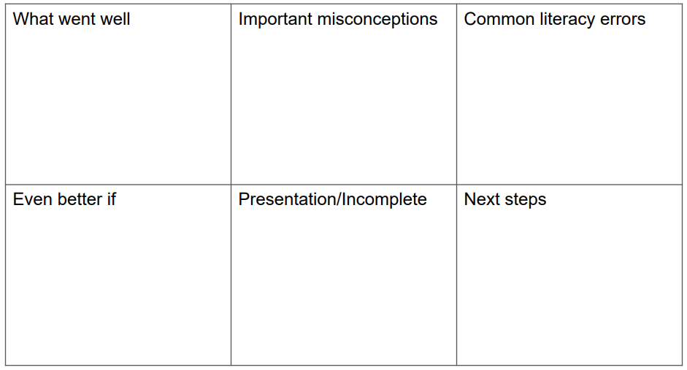
Thinking about your individual subject area what would you need to add or remove from this proforma to ensure you were addressing the needs of your subject:

How can you counteract the negatives of whole class feedback?

Disadvantages | How to counteract the disadvantages?
Can be too generic

Lacks personalization and may impact on engagement

Learners don’t take ownership and act on feedback

Activity 5
Aims:
Complete the reflective questions before watching the self and peer feedback section of the video (36m56s – 42m42s). Then complete the key takeaways task.

Reflective questions before starting the session…
- What benefits can you see emerging from using Peer and Self-Feedback?

- What do you see as the likely pitfalls of Peer and Self Feedback?

- Have you tried any Peer and Self Feedback? What was the outcome?

Key takeaways that you will consider implementing in your teaching practice:

Reading List

- Christodoulou, D., (2017) Making Good Progress, Oxford: OUP

- DFE – (2014-15) Workload Challenge Consultation Workload challenge: analysis of responses - GOV.UK (www.gov.uk) (Accessed 02/03/2021)

- DFE – (2016) – Reducing Teacher Workload Reducing teacher workload: Marking Policy Review Group report - GOV.UK (www.gov.uk) (Accessed 02/03/2021)

- EEF (2016) A Marked Improvement? Available at: Written marking | Education Endowment Foundation | EEF (Accessed: 30/12/2020)

- EEF (2014) Teaching and Learning Toolkit. Available at: Teaching and Learning Toolkit (educationendowmentfoundation.org.uk) (Accessed: 30/12/2020)

- Hattie, J., & Clarke, S., (2019) Visible Learning | Feedback, Oxon: Routledge

- Sherrington, T., (2019) Rosenshine’s Principles in Action, Woodbridge: John Catt

