Meeting the needs of all learners (including high ability)
Secondary NQT CPD Package

Resource Pack
To be completed alongside viewing the accompanying video.

Contents
1. Understand and reflect upon the needs of your students, their barriers to learning and your barriers to supporting them. 3

2. Identify opportunities to enable all students to experience success in learning. 7

3. Evaluate a range of strategies to enable all learners to succeed. 12

4. Reflect and Review 18

References and Further Reading 20

1. Understand and reflect upon the needs of your students, their barriers to learning and your barriers to supporting them.

Who are our learners and what are their needs? Think about a lesson that you taught recently:

Class ____________ Subject/Topic ___________________________

  - What were the differing needs of your students?

  - Were all of these explicit? What implicit needs may you have been unaware of?

  - How did you attempt to meet these needs?

What are your initial responses to these key questions (you will return to these at the end of this section):
  - What are students’ barriers to learning?

  - What does effective differentiation look like?

- Reflect upon the needs of all individuals in the class. Think about:

  - How greatly their needs differ?
  - What are the various barriers to learning?

Annotate the diagram below to organise your thoughts.

- Think about the various definitions and thoughts surrounding differentiation below:
    - Providing opportunities for optimal learning, differentiation should be for individualisation (Petty 2004)

    - Streaming or grouping students based on ability; dividing students based on comparative ability (Terwell 2005)

    - To adapt teaching, learning and assessment using a range of methods to teach a range of students and meet their needs within the same environment (Vickerman 2009)

    - A way to meet the needs of the most able (Hertberg-Davis 2009)

    - A way to provide different pathways to allow students to reach an expected standard and to extend beyond (Brighton et al 2005)

- What are the different ways to differentiate as presented by these definitions? Why might this be problematic?

- Which definition do you think matches your current style of differentiation?

- Does this align with where you would like to be?

- Note space: what are some of the common issues of differentiation according to Taylor (2017)?

- Thinking about these pitfalls and the statements below:

Greater emphasis on inclusive and adaptive teaching that considers all learners in a common curriculum rather than focused on difficult-to-sustain, multifaceted programmes and activities in a classroom of mixed-ability students (Taylor 2017; Westwood, 2013)

Differentiation—the key to effective differentiation is to know students well, to avoid labelling them, to diagnose their prior attainment accurately in order to apply differentiation flexibly (EEF 2018a)

  - How could you adjust your practice to take these factors into account? (just initial ideas).

  - What might the advantages of this be?

- Look again at these key questions, reflect upon any developments in your thinking:
  - What are students’ barriers to learning?

  - What does effective differentiation look like?

2. Identify opportunities to enable all students to experience success in learning.
- What are your initial responses to these key questions (you will return to these at the end of this section):
  - How might student/teacher views limit learning?

  - How can we apply this to teaching and learning?

  - How can an understanding of working memory and cognitive load theory help us to differentiate effectively?

  - How can slight adjustments to daily practice help us achieve this?

- Use the space below to record notes/ideas/reflections regarding these two teacher behaviours and how they can help us to meet the needs of all learners effectively.
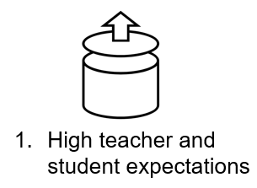 | 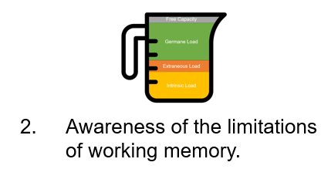
- Think of a topic you teach and how you teach it:
  - what are the cognitive demands of that topic?
  - What extraneous load does the task add?
  - Do your supports and scaffolds add to or reduce the extraneous load?

Visualise the cognitive demands of the task using the inside of the diagrams below. Then, plan adjustments on the outside of the diagram:

- Thinking more generally now about your subject area, what areas might you need to maximise, minimise or manage?

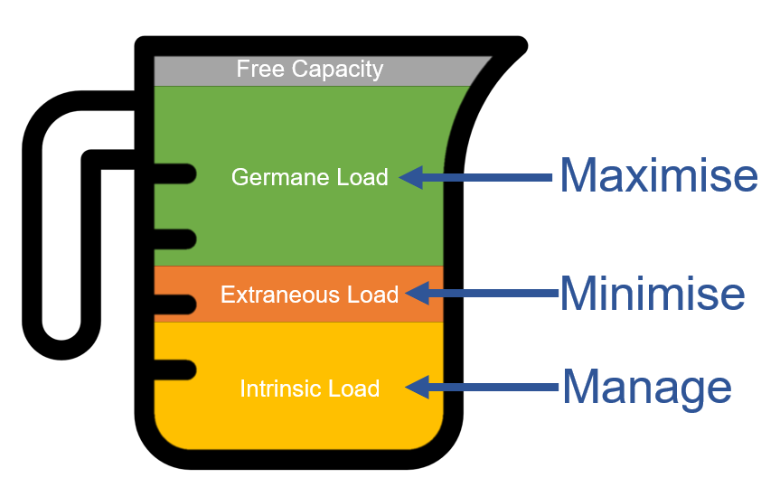

- Think once again about the class and lesson you have been reflecting on so far:

  - How do your students view themselves? How did you know this?

  - What was the climate of the room like? How did you try to build a positive classroom climate and a culture of success?

  - How did they react when they struggle?

  - How did you react to support them?

  - Did you manage cognitive load in the resources you provided to students?

  - How might you do things differently next time?

- Notes space: record your thoughts on what makes effective retrieval practice and how this helps us meet the needs of all learners.

Look again at these key questions, reflect upon any developments in your thinking:
  - How might student/teacher views limit learning?

  - How can we apply this to teaching and learning?

  - How can an understanding of working memory and cognitive load theory help us to differentiate effectively?

  - How can slight adjustments to daily practice help us achieve this?

Evaluate a range of strategies to enable all learners to succeed.
- What are your initial responses to these key questions (you will return to these at the end of this section):
  - What is differentiated instruction?

  - What is scaffolding?

  - How can we ensure an effective scaffold design?

- Record your understanding of differentiated instruction in the grid below and reflect upon what you already do?

Pro-active and deliberate adaptations of: | What adjustments might this include? | How am I already doing this? | How effective is this in my practice currently? (does it put a lid on learning or overload students?) | How could I improve this to better meet the needs of all learners?
Practice
Content
Process
Product
Learning environment/time
Assessment/ interest/ learner preference

- Reflect upon the strategies for differentiation below and link them to your own context. There is additional space for reflection after you have tried a strategy so that you can make any necessary adjustments.

Strategy | Whose needs and how does it meet them? | Does it limit learning? | How can you reduce /manage cognitive load? | How could this be adapted to fit my subject area? | Reflection 1 | Reflection 2 | Reflection 3
Differentiated student and teacher questioning.
Dual-coding to break down complex concepts.
The way you present the same content or adjust content for class sets.
Recall and modelling of differentiated processes.
Bronze, silver, gold tasks.
Think/Pair/ Share as a differentiation approach or hinge.
Differentiated feedback instruction.

- Corno (2008) talks about the effectiveness of micro-adaptations. These allow for instantly personalised lessons but differ from differentiated instruction as they are not pre-planned. Instead, they draw upon the teacher’s pedagogical and subject knowledge as well as their classroom experiences of what has worked in the past.
  - Did you make any micro adaptations in the lesson you are reflecting on?

  - Were they successful? Why/why not?

  - What makes a micro adaptation successful?

  - What should you be careful of when making micro adaptations?

- Notes space: record your thoughts on what makes effective scaffolding.

- Use the grid below to plan your own effective scaffolds for your context.

Topic/task | Who needs scaffolding? why? | Break down the components of the task | Detailed level supports | Overview level supports | How can I offer support at varying levels | How will I take it down | Reflect on the impact and plan adjustments

- Look again at these key questions, reflect upon any developments in your thinking:
  - What is differentiated instruction?

  - What is scaffolding?

  - How can we ensure an effective scaffold design?

4. Reflect and Review
- Based on the lesson you reflected on earlier; below, summarise what might you do differently now?

Success Criteria
- Small adjustments for the biggest impact
- Scaffold without putting a lid on learning
- Reduce Extraneous Load
- Prepare explanations for common misconceptions
- Flexibility
- Questioning/AFL
- Student groupings

- Based on this session, make 3 pledges of simple ways you can adjust the ways you support students to overcome barriers to learning.

I am going to… | I will try this by… | Upon reflection next time I will… | I will try this again by… | I will embed this into my practice by…

Remember, you can reuse this booklet to reflect on different strategies and to plan for different groups of learners.

References and Further Reading
@__codexterous (2020) Cracking Open GCSE English Language: A Granular Method of Preparation (2020). Available at: https://codexterous.home.blog/2020/08/29/cracking-open-gcse-english-language-a-granular-method-of-preparation/ (Accessed: 31 December 2020).
Caviglioli, O. (2020) Dual coding with teachers. Woodbridge: John Catt Educational ltd.
Corno, L. (2008). ‘On teaching adaptively’. Educ. Psychol. 43, 161–173. doi: 10.1080/00461520802178466
Department for Education (2017) SEN support: A rapid evidence assessment. Research report.. Social Science in Government, pp. 19-25.
Dweck, C. (2007) Mindset: The New Psychology of Success. New York, NY: Ballantine Books.
EFF (2018a) ‘Best Practice in Grouping Students Intervention B: Mixed Attainment Grouping Pilot report and executive summary’. Millbank: National Foundation for Educational Research. Available at: https://educationendowmentfoundation.org.uk/public/files/Projects/Evaluation_Reports/Intervention_B_-_Mixed_Attainment_Grouping.pdf (Accessed: 13 January 2021).
EFF (2018b) ‘Teaching and Learning Toolkit: Collaborative learning’. Available at: https://educationendowmentfoundation.org.uk/pdf/generate/?u=https://educationendowmentfoundation.org.uk/pdf/toolkit/?id=152&t=Teaching%20and%20Learning%20Toolkit&e=152&s= (Accessed: 3 January 2021)
EFF (2018c) ‘Teaching and Learning Toolkit: Within-class attainment grouping’. Available at: https://educationendowmentfoundation.org.uk/pdf/generate/?u=https://educationendowmentfoundation.org.uk/pdf/toolkit/?id=2618&t=Teaching%20and%20Learning%20Toolkit&e=2618&s= (Accessed: 3 January 2021)
Hertberg-Davis, H. (2009) ‘Myth 7: Differentiation in the Regular Classroom Is Equivalent to Gifted Programs and Is Sufficient Classroom Teachers Have the Time, the Skill, and the Will to Differentiate Adequately’. Gifted Child Quarterly, 53 (4), pp. 251-253.
Johnson, David & Murayama, G & R.T., Johnson & Nelson, D & Skon, L. (1981). ‘Effects of cooperative, competitive, and individualistic goal structures on achievement: A meta-analysis’. Psychological Bulletin, 89. pp. 47-62. Doi: 10.1037/0033-2909.89.1.47. Available at: https://www.researchgate.net/publication/229067919_Effects_of_cooperative_competitive_and_individualistic_goal_structures_on_achievement_A_meta-analysis/citation/download (Accessed 16 January 2021)
Jones, K. (2020) Retrieval Practice: Research and Resources for every classroom. Woodbridge: John Catt Educational, Limited.
Lovell, O. (2020) Sweller's Cognitive Load Theory in Action. Woodbridge: John Catt Educational Ltd.
Marks, R. (2013) ‘’The Blue Table Means You Don't Have a Clue': the persistence of fixed-ability thinking and practices in primary mathematics in English schools’. FORUM, 55(1), p. 31. doi: 10.2304/forum.2013.55.1.31.
Maslow, A. H. (1943). ‘A theory of human motivation’. Psychological Review, 50(4), 370-96.
Rosenshine, B. (2012) American Educator, 36(1), pp. 12-19. Available at: https://files.eric.ed.gov/fulltext/EJ971753.pdf (Accessed: 10 December 2020).
Rosenthal, R. and Jacobson, L. (1968) ‘Pygmalion in the Classroom’. American Educational Research Journal, 5(4), p. 708. doi: 10.2307/1162010.
Roseth, C., Johnson, D. and Johnson, R. (2008) ‘Promoting early adolescents' achievement and peer relationships: The effects of cooperative, competitive, and individualistic goal structures’. Psychological Bulletin, 134(2), pp. 223-246. doi: 10.1037/0033-2909.134.2.223. Available at: https://pdfs.semanticscholar.org/7af4/b797f4cf9877760c7bf87934a75f037c9b5c.pdf (Accessed 16 January 2021)
Roy, A., Guay, F. and Valois, P. (2013) ‘Teaching to address diverse learning needs: development and validation of a Differentiated Instruction Scale’. International Journal of Inclusive Education, 17(11), pp. 1186-1204. doi: 10.1080/13603116.2012.743604.
Sherrington, T. (2019) Rosenshine's Principles in Action. Woodbridge: John Catt Educational Ltd.
Sherrington, T. and Caviglioli, O. (2020) Teaching Walkthrus. Woodbridge: John Catt Educational Ltd.
Smale-Jacobse, A. et al. (2019) ‘Differentiated Instruction in Secondary Education: A Systematic Review of Research Evidence’. Frontiers in Psychology, 10. doi: 10.3389/fpsyg.2019.02366.
Sweller, J. Ayres, P. and Kalyuga, S. (2011) Cognitive Load Theory. New York, NY: Springer New York.
Taylor, S. (2017) ‘Contested Knowledge: A Critical Review of the Concept of Differentiation in Teaching and Learning’. Warwick Journal of Education–Transforming Teaching, 55.
Terwel, J. (2005) ‘Curriculum differentiation: multiple perspectives and developments in education’. Journal of Curriculum Studies, 37 (6), pp. 653-670. doi: 10.1080/00220270500231850.
Tomlinson, C. A. (2014) The Differentiated Classroom. Responding to the Needs of All Learrners, 2nd Edn. Alexandria, VA: ASCD.
Vickerman, P. (2009) ‘Differentiation - guidance for inclusive teaching’. Available at: http://webarchive.nationalarchives.gov.uk/20101021152907/http:/www.ttrb.ac.uk/ViewArticle2.as px?anchorId=17756&selectedId=17759&menu=17834&expanded=False&ContentId=15712 (Accessed: 13 January 2021)
Westwood, P. (2013) Inclusive and Adaptive Teaching. London: Routledge.

