Behaviour
Primary NQT CPD Package

Resource Pack
To be completed alongside viewing the accompanying video.

Contents
Activity 1 Defining behaviour Page no.3
Activity 2 Considering examples of poor behaviour Page no.4
Activity 3 Video from Future Learn Page no.5
Activity 4 Setting ground rules Page no.6
Activity 5 Optimal learners Page no.7
Activity 6 ACEs Page no.8
Activity 7 Case study 1 Page no.10
Activity 8 Case study 2 Page no.11
Activity 9 Reflecting on learning behaviours Page no.12
Activity 10 Evidenced-based programmes Page no.13
Behaviour Toolkit Page no.14
References Page no.18

Check List

Before starting a role within a school, follow this checklist to ensure you have a strong grounding of your behaviour expectations and understanding.

- Read the behaviour and bullying policies

- Identify SEN and vulnerable children within your class

- Seek additional information from school staff about behaviour of your class. Create a profile of any ‘characters’.

- Understand what the school behaviour approach is. Are there strategies in place or do you need to create your own rewards, sanctions and behaviour expectations resources?

Activity 1 (Slide 5)
Aims: To understand behaviour in the context of the Primary setting.

Task: In your own words, define your understanding of behaviour.

Activity 2 (Slide 11)
Aims: To understand what constitutes ‘poor’ behaviour.

Task:
- Consider an example of negative behaviour you have experienced from a pupil. What was the context? How did you react to it/deal with it?
- Would you deal differently with it in future?
- Having considered this example, how would you describe your behaviour management approach?

Activity 3
Aims: To recognise the value of scripting behavioural conversations.
Task: Watch The following clip.
www.futurelearn.com/info/courses/managing-behaviour-for-learning/0/steps/16013
Draft a conversation between yourself using a pre-set behaviour script and a pupil who is displaying defiant and disruptive behaviour.
**You may include more than one possible outcome**

Activity 4 (Slide 20)
Aims: To understand the importance of setting ground rules for your classroom.
Task: Draft your own set of ground rules to implement.
Refer to the ECF on behaviour to support this. Early Career Framework (publishing.service.gov.uk)

Activity 5 (Slide 23)
Aims: To understand and recognise the optimal learner.
Task: Using the quadrant model below, consider a pupil you have encountered who sits in one or all of these quadrants. You can choose more than one pupil if you have examples. It is important to note that a pupil may move between some of these quadrants throughout the course of day.
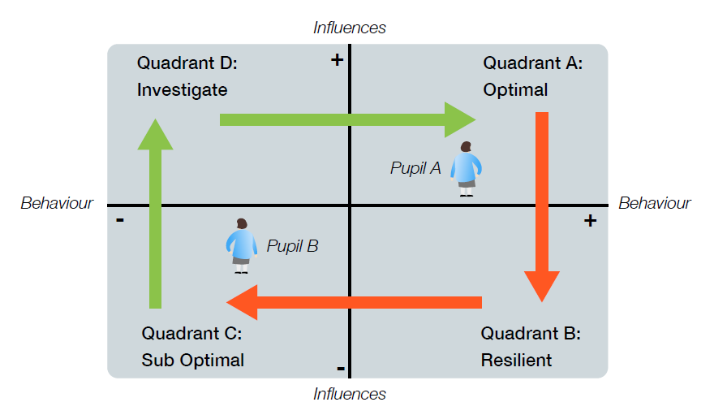

Consider how you might support a pupil who is in each of these stages.

Activity 6 (Slide 32)
Aims: To develop and awareness of ACEs in the context of the classroom.
Tasks:
i.) Which behaviours/character traits may indicate an ACE?
ii.) Outline three childhood events which may constitute an ACE.

Reflection Point
As a practitioner you will not be expected to have an in-depth, psychological understanding of ACE’s and their impacts. However, it is important that you have an awareness of their characteristics and potential courses of action.
You have identified a pupil in your class to be displaying characteristics that may suggest an ACE.
- What possible actions could you take to gather further information/evidence?

- What possible actions could you take to support the pupil? (These won’t necessarily all be actions to be completed by you, however you need to consider who may be able to support internally and externally).

Activity 7 (Slide 33)
Aims: To identify actions and solutions for specific behaviours.
Task: Case Study 1. Set out a list of actions you would complete to begin supporting this child’s behaviour.
Seb is a year 5 pupil. He displays ADHD behaviours and is mostly disengaged from learning. He will use known strategies to avoid completing tasks, including sabotaging work he has started, even when there’s nothing wrong with it.
There are some known triggers which staff try to avoid: Assemblies, transition and play times, writing and spelling sessions and group work.
He lives with mum and a younger sister. He doesn’t see dad very much and if he ever stays with him, comes back agitated and volatile.
Seb has shown some excellent skills and abilities but does not accept praise easily. The assessments he has been able to complete have indicated expected standard.
Seb will often fly into a rage and shout and swear at other pupils and members of staff. In some severe episodes he has been known to ‘rampage’ around the school, kicking doors and resulting in his classroom being evacuated.
He has a poor attendance record (below 90%), often struggling to get into school and he has received short term exclusions.

Actions

Activity 8 (Slide 40)
Aims: To identify actions and solutions for specific behaviours.
Task: Case Study 2. Set out a list of actions you would complete to begin supporting this child’s behaviour.
Lillie is in Year 2. She is a happy pupil and is always smiling and rarely gets pulled into disagreements with other pupils.
In class, Lillie appears fidgety and distracted. She shouts out and makes noises such as animal calls. She frequently ‘derails’ the learning, however this seems involuntary.
She presents as ‘hyper’ in the mornings and then after lunch will dip and struggle to keep her eyes open.
She is one of five children and mum is busy and has struggled with her mental health.
Lillie loves anything to do with space and astronomy. Her eyes light up when discussing this topic and she is extremely knowledgeable about it.
It’s a running joke from her family and friends that she is ‘clumsy’ and ‘disorganized’. Once when asked why she turned off the light switch during a lesson, she said “My head did it.”
She hates Maths!

Actions

Activity 9 (Slide 43)
Aims: To reflect on learning behaviours
Task:
- What are the benefits of cognitive learning behaviour approaches?

- What are some of the risks and potential challenges?

- How could you implement an emotional learning behaviours approach in your practice? How would you get the pupils to assess and respond to their emotional states throughout the day?

Activity 10 (Slide 46)
Aims: To identify and understand evidenced-based programmes which help support and augment behaviour and learning in the Primary classroom.
Guidance:
There are number of behavioural and learning behaviour support programmes, however they must be evidence-based to ensure monitoring and targets can be satisfied.
The EEF is the ‘go-to’ organisation for referencing a vast array of evidence-based approaches.
EEF Teaching and Learning Toolkit

There are also a number of evidence-based websites:
Evidence4Impact
Evidence 4 Impact (E4I) is an independent service that provides teachers and school leaders with accessible information on which educational interventions have been shown to be effective. Search for ‘behaviour’ and there is a wealth of excellent information, including research on social skills and activities to help support children’s social interactions.
Evidence-Based Learning
Improving Social and Emotional Learning - Evidence Based Education
With collaboration from Durham University, they have an excellent page on improving social and emotional learning, all evidence-based.
The Great Teaching Toolkit
Whilst largely geared towards assessment and targets, the video and podcast on this site provides some excellent evidence-based research that feeds in to the need for excellent behaviour and high expectations.
The Great Teaching Toolkit: Evidence review - Evidence Based Education

Behaviour Toolkit
This is by no means an exhaustive list, however, may serve as a package of useful information when embarking on setting up your classroom learning environments.

- Ready, Respectful, Safe behaviour poster

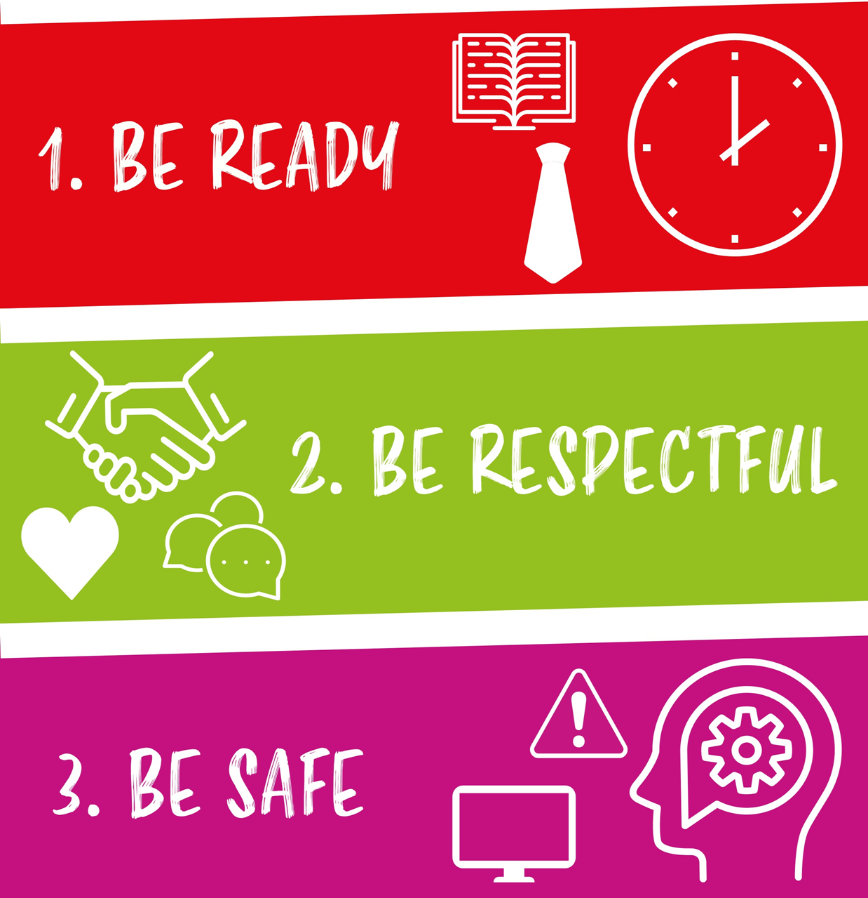

- Rewards and consequences table
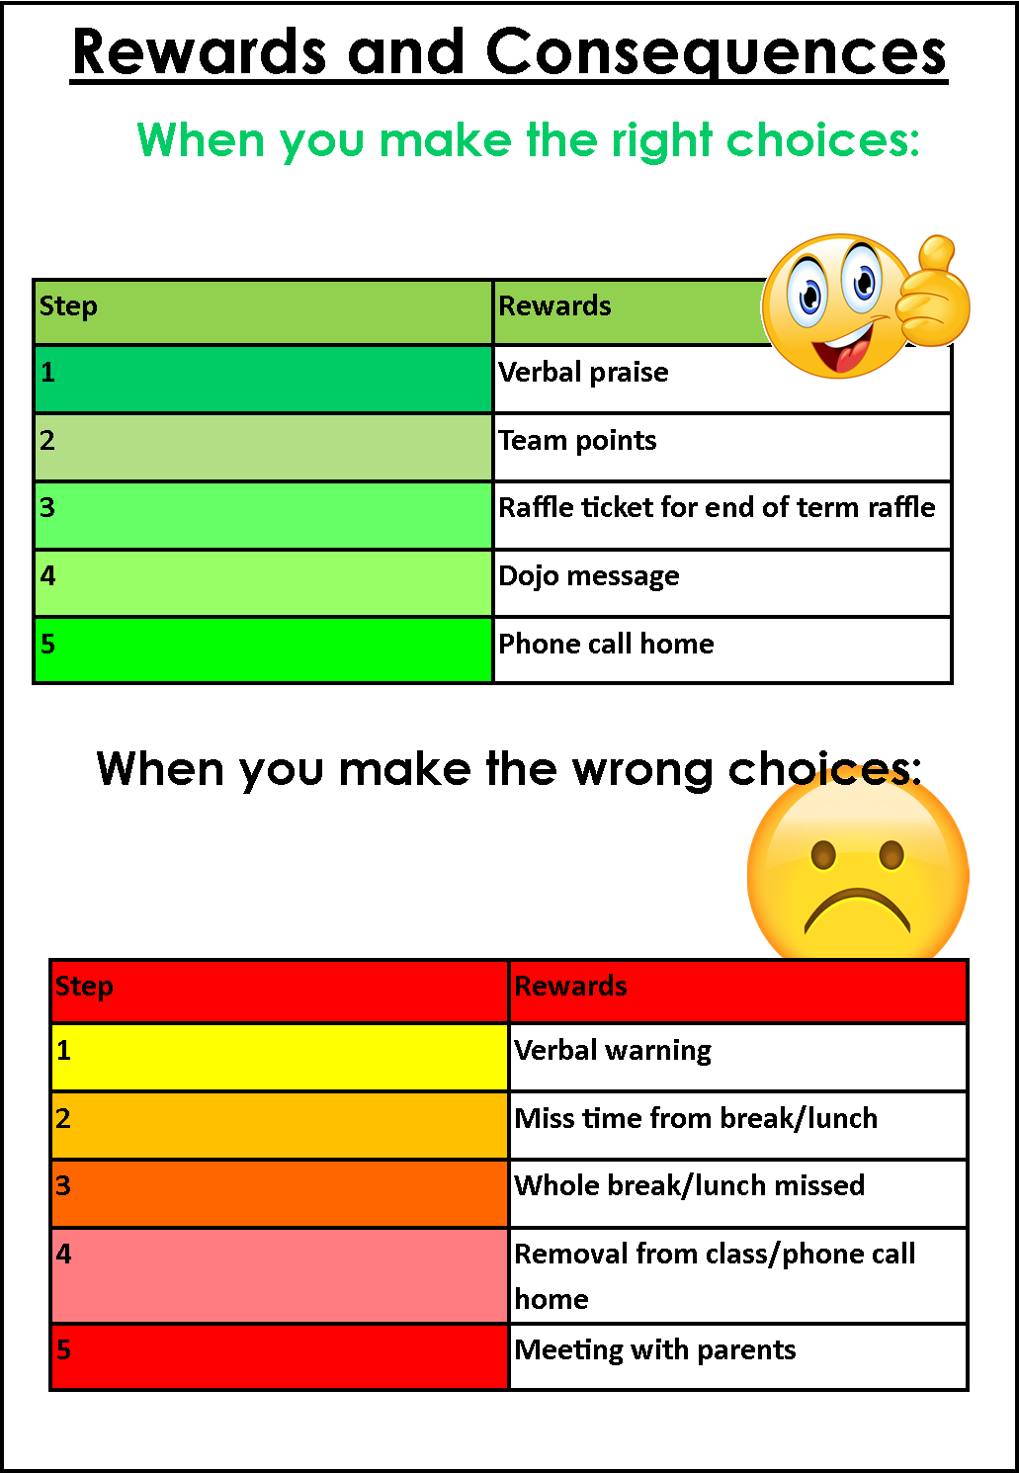

- Behaviour chart template
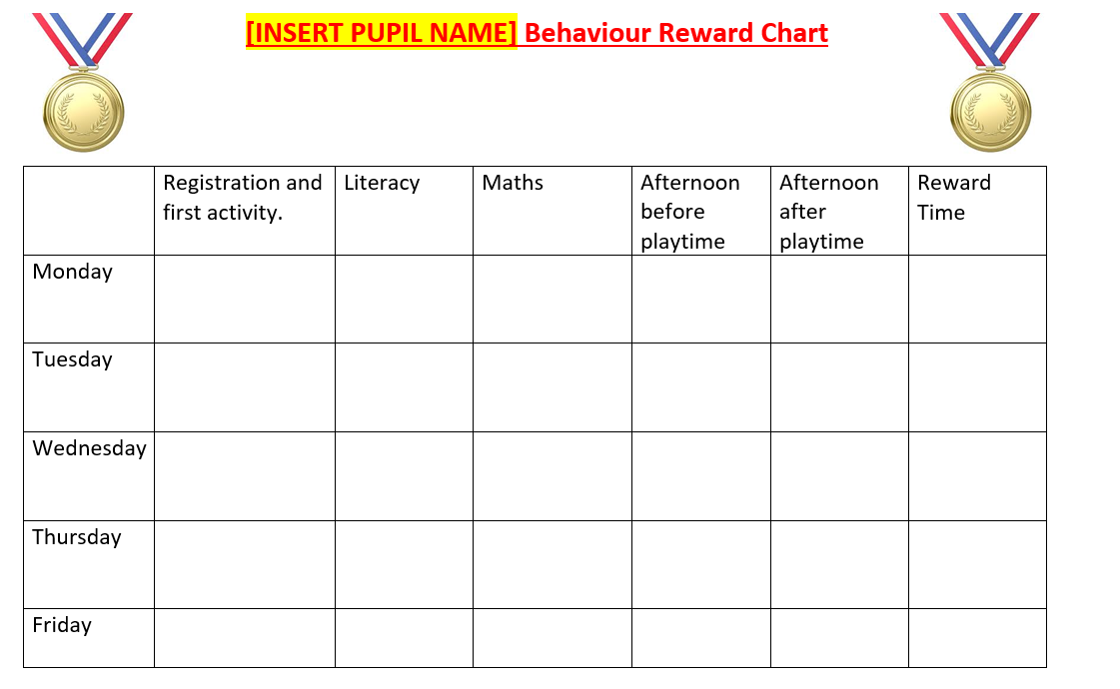

- Emotional behaviour descriptor cards

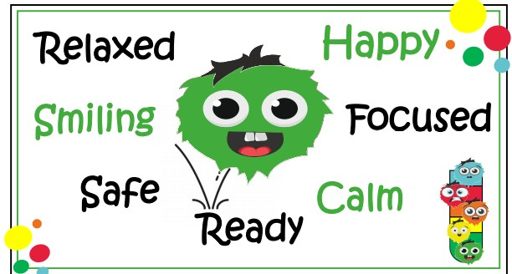
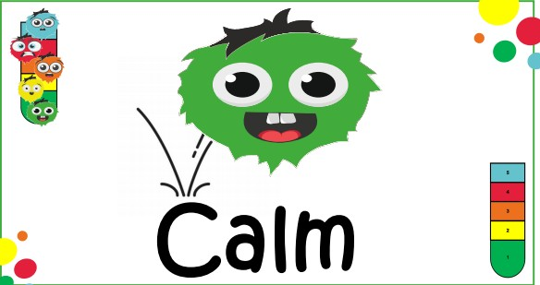
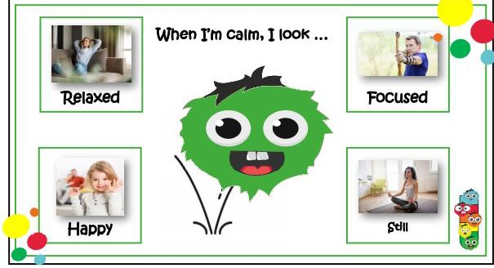
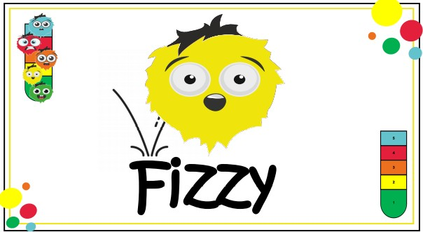
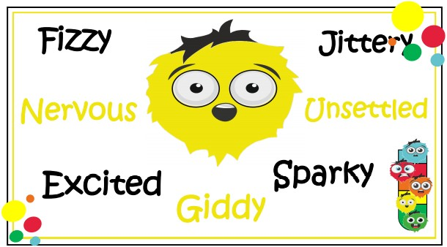
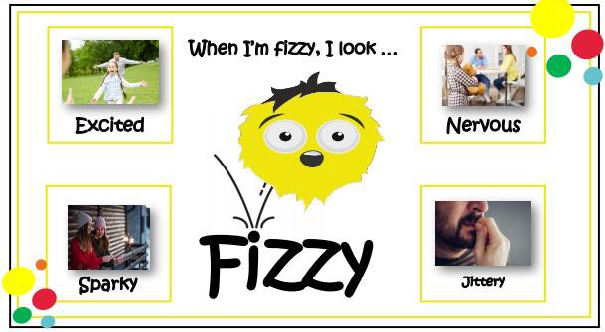
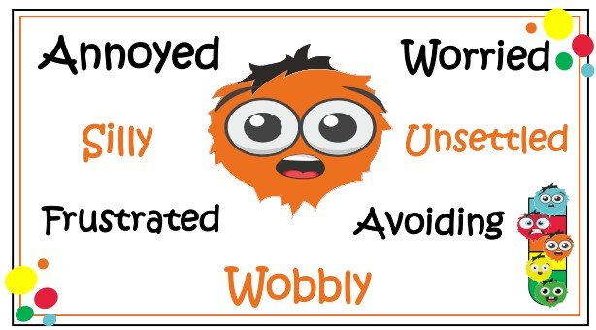
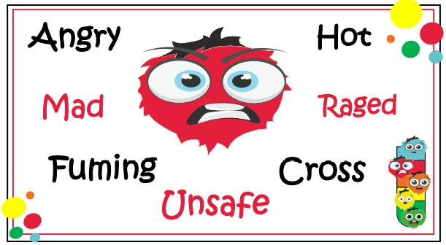
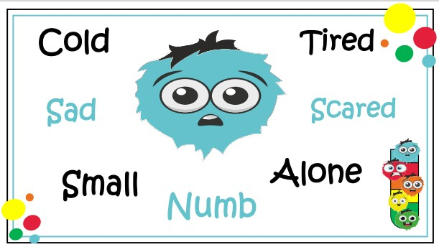

Further Reading
Dix, P. (2017) When the adults change everything changes: Seismic shifts in school behaviour, Crown House Publishing.
Dix, P. (2007) The essential guide to taking care of behaviour, Pearson Longman.
Bennett, T. (2010) The Behaviour Guru: Behaviour Management Solutions for Teachers, Continuum.
Cowley, S. (2006) Getting the Buggers to behave, Continuum.
References
Children’s Commissioner (2012) Practical Tips for Schools: outstanding safeguarding practice in primary schools. Available at:
https://dera.ioe.ac.uk/15496/2/Practical_Tips_You_Have_Someone_to_Trust_Final_Sept_2012%5B1%5D.pdf

Norlin, J. (2018) 3 Steps to Strengthen Relationships in Your Classroom. Available at:
https://www.characterstrong.com/blog/establishmaintainrestore

Ellis, S. and Tod, J. (2018) Behaviour for Learning: Promoting Positive Relationships in the Classroom, London: Routledge.

Powell, S, and Tod, J. (2004) A systematic review of how theories explain learning behaviour in school contexts. In: Research Evidence in Education Library. London: EPPI-Centre, Social Science Research Unit, Institute of Education.

Dweck, C., S. (2008) Mindset: the new psychology of success, New York: Ballantine Books.

