
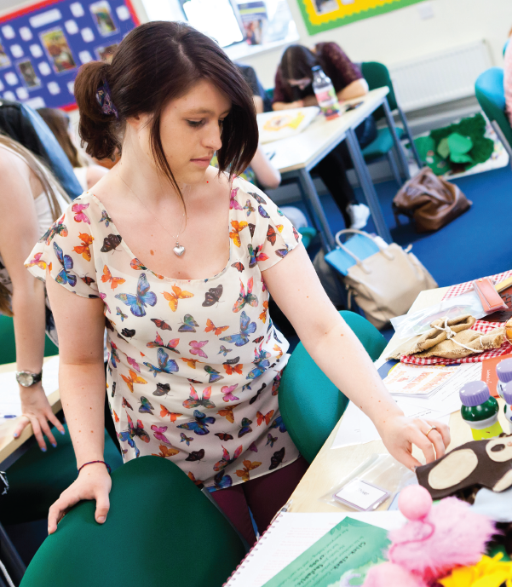

Maintaining Good to Outstanding during your ECT Induction
For Primary ECTs
TS 1: Set high expectations which inspire, motivate and challenge pupils

Introduction
We understand that your ECT induction can be very demanding and that there may be times when a little extra support may be needed. We have put together this guidance in order to help you maintain good to outstanding teaching across all of the Teachers’ Standards during your ECT induction. You may wish to use this booklet during discussions with your induction mentor to discuss specific activities and strategies and think about next steps.

TS 1: Set high expectations which inspire, motivate and challenge pupils
An outstanding ECT:
- Consistently uses innovative strategies to establish a safe and stimulating environment for pupils, rooted in mutual respect, which motivates and inspires pupils to learn and enjoy the subject.
- Consistently sets goals that stretch, challenge and motivate pupils, and uses strategies to support the progress of underperforming groups.
- Consistently and effectively demonstrates and models the positive attitudes, values and behaviour which are expected of pupils.

Teachers’ Standard sub headings:
- establish a safe and stimulating environment for pupils, rooted in mutual respect
Consistently uses innovative strategies to establish a safe and stimulating environment for pupils, rooted in mutual respect, which motivates and inspires pupils to learn and enjoy the subject.

Strategies
- Safeguarding – Ensure that your own safeguarding practice matches the policy of the school
- The classroom environment – Consider how well the learning environment supports and extends learning. Be prepared to make adaptations to groupings and table arrangements, especially if this will result in greater pupil progress. Plan for these adaptations in your future sequences of lessons. Establish a relaxed atmosphere within class – pupil talk; confidence to speak and discuss; respect for opinions of others; linking to:
- Behaviour in lessons – Ensure that you set consistently high expectations of pupil behaviour which are centred on promoting learning and a safe environment. Consider your use of rewards and sanctions (including celebration assemblies, class assemblies) and ensure these follow the school policy for behaviour. Communicate your expectations clearly and consistently.
- Adaptive teaching and grouping - all pupils always find the work accessible yet challenging, including target groups (pupil premium, SEN/D, EAL, LAC and Higher achieving pupils). Vary your approach to sets/grouping of the pupils; consider grouping by ability or mixed ability which is flexible and adaptive, and again change this within different subject areas to ensure progress. Reflect upon the effective use of other adults to support learning across the entire ability range. Be aware of the Pygmalion Effect (Rosenthal and Jacobsen,1968) and its impact on teacher expectations
- Lesson observations and use of display - collect a portfolio of (stimulating) displays (which represent minorities e.g. disabled, ethnic groups, etc.) and seek opportunities to mirror effective practice by experienced staff in school. Specifically look for examples of stimulating environments, high expectations and use of the pupil voice.
- Learning outcomes- Allow the pupils to set/ assist in setting the success criteria. Allow them ownership of their own learning outcomes and progress.
- set goals that stretch and challenge pupils of all backgrounds, abilities and dispositions
Consistently sets goals that stretch, challenge and motivate all pupils.

Strategies
- Consistently reflect on your own teaching- ask yourself (and your mentor): what can I do next? What worked well? Why did it work? What could I do next time to ensure all pupils are challenged and motivated? Did the activity generate the desired outcome for all pupils?
- Target setting and Assessment for Learning- Do the children know their targets and how to meet them; next steps marking; AfL is embedded
- Interventions – Do specific targets and interventions show clear steps to goals and include opportunities for regular review?
- Quality lesson planning - which shows clear and appropriate adaptive teaching strategies; seating plans/groupings; effective use of other adult support and expertise
- Observe other teachers - Seek opportunities to observe experienced staff and consider the teaching techniques used; reflect how you could build these techniques into your own teaching.
- Speak to the SENCO to seek advice about specific individuals- look at the suggested activities/strategies along with the learning needs outlined in the support plan. Speak to the TA who works with the pupil(s) asking for advice and guidance. Consistently plan your lesson using the TA as a resource.
- Effective use of other adults it the room- consistently plan how you intend to use the TA and ask their advice when planning the lesson. They may have strengths and knowledge you don’t know about. Clearly plan for the use of other adults on your lesson plan.
- Awareness of vulnerable children/groups – attend pupil progress meetings where possible; collect evidence showing understanding/impact of vulnerable children’s needs; teacher tracking data with interventions
- demonstrate consistently the positive attitudes, values and behaviour which are expected of pupils.
Consistently and effectively demonstrates and models the positive attitudes, values and behaviour which are expected of pupils.

Strategies
- Model the behaviours you wish to see - respect, politeness expected in and outside class to other colleagues and visitors, not just children
- Behaviour around school – transition times, in the playground, time keeping
- Develop relationships with outside agencies and the community - trips out, parents’ feedback
- Follow the school’s behaviour policy consistently - including sanctions, rewards, code in & out of classroom; displays of pupils’ work; class charter/rules are displayed
- Feedback - to pupils on behaviour and attitudes as well as their work
- Demonstrate the values of school – in your interactions and teaching
- Allowing for collaborative learning- plan for group tasks that are truly collaborative (think about your setting and roles for the pupils to undertake) not forgetting to build in feedback and reflection of the task from a pupil’s perspective.
- Demonstrate an interest in, and commitment to, each child as an individual
- Resilience – seek ways to develop pupil resilience and mind-sets

TS1 in the Foundation Stage
In addition to the sections above, also consider…
- Recognise that children are competent learners from birth, who can be resilient, capable and confident, and encourage them to play, explore, persist, create and think critically.
- Create an environment that is supportive and stimulating and which builds upon their prior learning.
- Encourage and value the different ways in which children may represent their experiences.
- Sustained shared thinking – always be alert to opportunities to develop individual children’s thinking through sustained interaction focusing on the child’s own activities and interests.
- Developing good communication – follow good practice guidance to ensure effective communication with all children, especially those with SLCN.
- Identifying children’s genuine interests and preoccupations – including those of quieter and less assertive children – and plan to support these creatively.
- Working with families – actively seek out the views of parents and carers in order to meet children’s learning needs more effectively.

