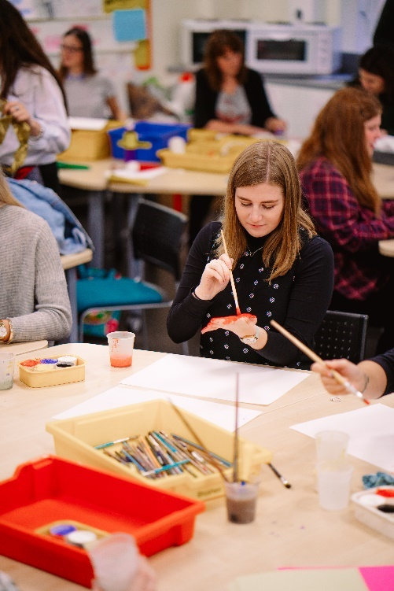
Maintaining Good to Outstanding during your ECT Induction
For Primary ECTs
TS 2: Promote good progress and outcomes by pupils

Introduction
We understand that your ECT induction can be very demanding and that there may be times when a little extra support may be needed. We have put together this guidance in order to help you maintain good to outstanding teaching across all of the Teachers’ Standards during your ECT induction. You may wish to use this booklet during discussions with your mentor to discuss specific activities and strategies and think about next steps.

TS 2: Promote good progress and outcomes by pupils

An outstanding ECT:
- Is consistently accountable for pupils’ attainment, progress and outcomes.
- Has a detailed understanding of the pupils’ capabilities and their prior knowledge.
- Consistently provides high quality intervention and feedback to pupils which enables them to reflect on the progress they have made and their emerging needs and understand what they need to do to improve
- Is consistently and effectively able to use knowledge and understanding of how pupils learn to improve their teaching.
- Consistently and effectively encourages pupils, by setting specific high expectations, to take a responsible and conscientious attitude to work and study.
Teachers’ Standard sub headings:
- be accountable for pupils’ attainment, progress and outcomes
Is consistently accountable for pupils’ attainment, progress and outcomes.

Strategies
- Risk taking - be prepared to try something new (it might not always work but you will learn from this).
- Flexibility- be prepared and confident. Consistently think about how you can adapt your teaching throughout the lesson. Be prepared to follow a different route (away from your lesson plan) especially if this will result in more pupil progress. Allow the pupils to lead their own learning, and plan for this in your future sequence of lessons.
- Differentiation- all pupils always find the work accessible yet challenging, including target groups (including: Pupil premium, SEN/D, EAL, LAC and Higher achieving pupils) Vary methods of differentiation e.g. by resource, by outcome, by support, as well as by ability based task. N.B. Extending high achievers does not mean additional work, it means deepening and applying their understanding. In the same way SEND does not mean less - just a different approach.
- Grouping - vary how to set/group your pupils; consider grouping by ability and again change this within different subject areas to ensure maximum progress. Actively and consistently reflect upon the effective use of other adults, for example, don’t only use other adults to support those with SEND or lower ability
- Feedback- marking should consistently be meaningful and help to move the pupils on in their learning. Encourage the use of individual and peer assessment. Ensure there are opportunities to evidence how pupils have acted upon the feedback.
- Learning outcomes- Allow the pupils to set/ assist in setting the success criteria. Allow them ownership for their own learning outcomes and progress.
- be aware of pupils’ capabilities and their prior knowledge, and plan teaching to build on these
• Has a detailed understanding of the pupils’ capabilities and their prior knowledge.
• demonstrate through their planning and teaching that their pupils, including those who are disabled and those who have special educational needs, make good progress.

Strategies
- Consistently reflect on your own teaching- be honest with yourself, ask yourself, what can I do next? What worked well? Why did it work? What could I do next time to ensure all pupils are engaged and therefore make progress? Did the activity generate the correct outcome for the pupils?
- Assessment for learning- consistently track pupils’ progress, know the pupils starting point and plan accordingly for each pupil, also be specific for each subject area. Have an awareness of your target groups and reflect this in your planning?
- Flexibility with your plan: use a starter, if the pupils already have the knowledge/skills/understanding don’t make them carry out the task again, allow them to start from a different starting point otherwise you are limiting their progress.
- Teacher file/assessments and tracking - have clear and consistent tracking of ALL pupils. Highlight on your lesson plans your target groups and the adapted activities to be used to suit the needs of the pupils. SEND pupils use/read/speak to the TA about the school based support plans to enhance your teaching and beware of other target groups. (LAC/SEND/PP/Higher attaining pupils). Gather information and seek advice as how to cater for these target groups and ensure you track and reflect upon their attainment.
- Observe other teachers with strengths in specific teaching fields- Consider the teaching techniques used and reflect how you could build these techniques into your own teaching.
- Speak to the SENCO to ask advice about specific individuals- look at the suggested activities/strategies along with the learning needs outlined in the support plan. Speak to the TA who works with the pupil(s) asking for advice and guidance. Consistently plan your lesson using the TA as a resource.
- Seating plans- different plans could be used for different subjects, working on pupil ability and strengths.
- Effective use of other adults - consistently plan how you intend to use the TA and ask their advice when planning the lesson. They may have strengths and knowledge you don’t know about. Clearly plan for the use of other adults on your lesson plan. Do not routinely place the TA with lower ability groups.
- Be prepared- Have extension tasks ready (not more questions or a bolt on activity) but activities that deepen the learning or ask the pupils to use the learning in another context.

C) guide pupils to reflect on the progress they have made and their emerging needs
Pupils are consistently offered high quality intervention and feedback which enables them to identify the progress they have made and understand what they need to do to improve.

Strategies
- Flexibility- (see previous point) if the lesson is not working do not continue because that is the plan! Change and adapt to suit the needs of the pupils. Plan enhancing activities that deepen the pupils thinking. Allow them to transfer the skills they have used in another context.
- Evaluation- consistently ask pupils to reflect upon their own learning, then use this to inform your planning.
- Reviews – Begin each lesson with a review of previous learning; consider which words, vocabulary and ideas need to be reviewed
- Allowing for collaborative learning- plan for group tasks that are truly collaborative (think about your setting and roles for the pupils to undertake) not forgetting to build in feedback and reflection of the task from a pupils perspective.
- Mini plenaries (or pit stops)-Short snappy spot checks assessing pupil progress. Red/amber /green cards to check progress. 5 things learnt today, exit cards, and many more. Consider how will you record and use this snap shot for assessment.
- Other ideas-
-Peer evaluation; AfL
-Response to marking and feedback by learners
-Class environment promoting space for reflection
-Journals and diaries
-Learning Walls
-Pupil awareness of development target, short term targets
-Marking to success criteria; pupils select own success criteria.
- demonstrate knowledge and understanding of how pupils learn and how this impacts on teaching
Is consistently and effectively able to use knowledge and understanding of how pupils learn to improve their teaching.

Strategies
- Evaluating process- reflecting consistently on what you did and the impact this had on the children. How do you know they made progress? How can you show the pupils they have made progress?
- Planning a variety of lessons - consistently show within your lesson plans how you have tailored the learning to suit the needs of the pupils- use your lesson plan as a working document. Consistently annotate the plan to show how you have adapted the work, and then use this in your future planning.
- Scaffolding – Provide pupils with temporary supports and scaffolds to assist them when they learn new or difficult tasks; for example thinking aloud while modelling, providing checklists, anticipate errors pupils might make
- Questioning – Ask lots of questions and check for all children’s understanding at each point; questions help pupils practise new information and connect new material to their prior learning
- Lesson planning – for EAL, SEN/D, closing individual learning gaps.
- Lesson study – expert practitioners observe teachers within their areas of expertise.
- CPD/ staff training (and evidence of CPD in appropriate areas), keep constantly up to date with emerging theories and practice.
- Plan for and deliver varied and creative teaching styles- e.g. paired work, team teaching (not a single approach all lesson).
- Evidence of adapting lessons- in response to pupils’ needs through lesson evaluations, observations/ learning walks and annotate the plans as you go.
- encourage pupils to take a responsible and conscientious attitude to their own work and study
Consistently and effectively encourages pupils, by setting specific high expectations, to take a responsible and conscientious attitude to work and study.

Strategies
- Expectations – being consistent and explicit in your high expectations of the pace, focus, independence and quality of work.
- Responsibility – you take responsibility for ensuring that the pupils take responsibility for the quality of their work. Convey an understanding of the importance of hard work.
- Lesson planning – consistently plan for opportunities for pupils to take more responsibility for their learning e.g. in selecting different forms of recording/response, different routes to the same learning outcomes or flexibility in progressing to more challenging work when they are ready.
- Evaluation - consistent awareness of prior achievement and progress within a lesson, to support and challenge pupils on making appropriate decisions about their learning.
- Classroom climate – establishing a climate where it is safe for pupils to try things and take responsibility; safe in the assurance of your support and comfortable to be independent.
- Rewards - acknowledging responsible and conscientious attitude to their own work and study as well as achievement.
TS2 in the Foundation Stage
In addition to the sections above, also consider…
- Recognise that children are competent learners from birth, who can be resilient, capable and confident, and encourage them to play, explore, persist, create and think critically.
- Observation - Consistently make use of careful observation and thoughtful analysis of the evidence gathered to identify individual needs and then use to plan both enhancements to areas of provision and teacher led activities.
- Evidence pupil progress across all seven areas of learning and development.
- Encourage and value the different ways in which children may represent their experiences
- Exceeding expectations: where children are working beyond the expectations for the EYFS, consistently support them by deepening and broadening their learning rather than by moving on to a more formal curriculum.
- Record keeping – consistently use the school’s systems (or develop your own) to record observations and track progress
- Sustained shared thinking – always be alert to opportunities to develop individual children’s thinking through sustained interaction focusing on the child’s own activities and interests.
- Developing good communication – follow good practice guidance to ensure effective communication with all children, especially those with SLCN.
- Identifying children’s genuine interests and preoccupations – including those of quieter and less assertive children – and plan to support these creatively.
- Working with families – actively seek out the views of parents and carers in order to meet children’s learning needs more effectively.

