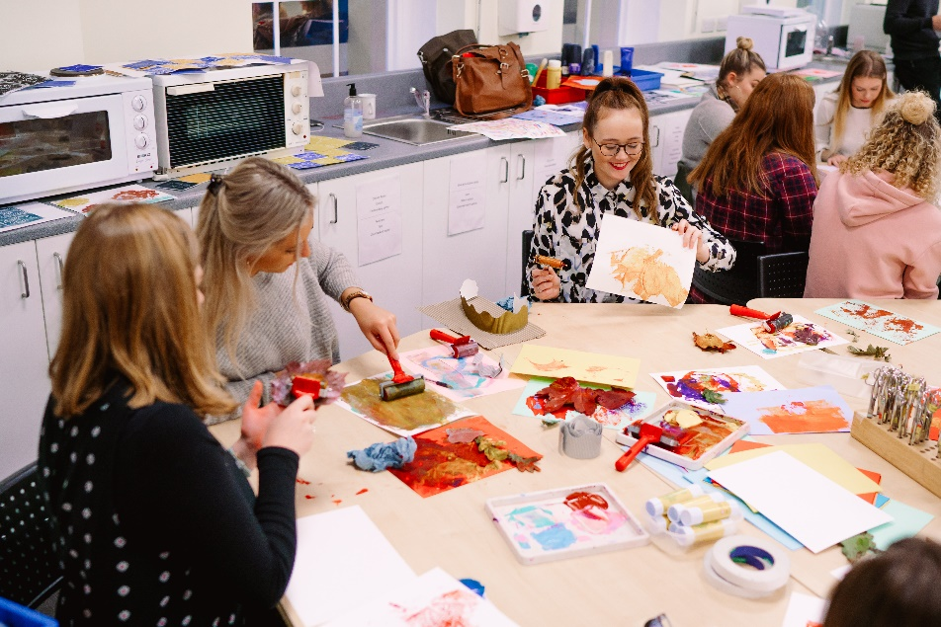
Maintaining Good to Outstanding during your ECT Induction
For Primary ECTs
TS 4: Plan and teach well-structured lessons

Introduction
We understand that your ECT induction can be very demanding and that there may be times when a little extra support may be needed. We have put together this guidance in order to help you maintain good to outstanding teaching across all of the Teachers’ Standards during your ECT induction. You may wish to use this booklet during discussions with your mentor to discuss specific activities and strategies and think about next steps.

TS 4: Plan and teach well-structured lessons

An outstanding ECT:
- consistently plans lessons using well-chosen, imaginative and innovative strategies that match the individuals’ needs and interests
- select and use available new technology to effectively support learning
- are highly reflective in critically evaluating their practice
- can accurately judge the impact of their practice on individual and groups of learners and can use their evaluation to inform future planning, teaching and learning
Teachers’ Standard sub headings:
- impart knowledge and develop understanding through effective use of lesson time

Strategies
- Risk taking- be prepared to try something new (it might not always work but you will learn from this).
- Flexibility- be prepared and confident. Consistently think about how you can adapt your teaching throughout the lesson. Be prepared to follow a different route (away from your lesson plan) if this will result in more pupil progress. Allow the pupils to lead their own learning, and plan for this in your future sequence of lessons.
- Meet the needs of all learners- all pupils always find the work accessible yet challenging, including target groups (including: Pupil premium, SEN/D, EAL, LAC and higher achieving pupils).
- Groupings - vary how to set/group your pupils; consider grouping by ability and again change this within different subject areas to ensure maximum progress. Actively and consistently reflect upon the effective use of other adults.
- Feedback- marking should consistently be meaningful and help to move the pupils on in their learning. Encourage the use of individual and peer assessment. Ensure there are opportunities to evidence how pupils have acted upon the feedback. Allow time for reflection within your lessons.
- Learning outcomes- Allow the pupils to set/ assist in setting the success criteria. Allow them ownership for their own learning outcomes and progress.
- Plan for the use of adults in the room – allow the adults in the room to help and assist with planning.
- promote a love of learning and children’s intellectual curiosity

Strategies
- Starting points – ensure that the learning starts from the interest of the children or is related to class or whole school topics
- Relevance – learning is set within context and the relevance is made clear to the children, including relating this to everyday situations.
- Learning outside the classroom – use the resources and the learning experiences all around you. How can you engage and inspire? Be different, learning does not have to take place within the classroom.
- Flexibility with your plan: If the pupils already have the knowledge/skills/understanding, don’t make them carry out the task again. Allow them to start from a different starting point otherwise you are limiting their progress.
- Observe other teachers with strengths in specific teaching fields - consider the teaching techniques used and reflect how you could build these techniques into your own teaching. How do these techniques engage and foster a love of learning?
- Use of displays – to engage the children and support their learning including revision and consolidation (links to homework possible here)
- Engagement in wider activities – to integrate national and international days and weeks into curriculum planning – e.g. World Book Day, Anti Bullying Week
- Enrichment opportunities – engage with opportunities outside the ‘usual’ week’s activities, for example mathematics week, external visits, ‘trips to the shops’ learning outside the classroom.

- set homework and plan other out-of-class activities to consolidate and extend the knowledge and understanding pupils have acquired
Strategies
NB – always follow the school’s homework policy
- Homework – link homework to the classroom learning, rather than seeing it as a ‘bolt on’. Ensure that it is actually deepening and/or building on existing knowledge and understanding. Try to follow up homework in some way e.g. link into future lessons or mark and give feedback.
- Accessible – homework needs to be accessible by all children; consider ways how to record the homework, the amount of support which is needed and possible adaptive teaching
- Research based homework – based on applying skills so that pupils can investigate topics which interest them or are linked to the whole class learning, always considering the enhancement of skills.
- Out of class activities – including a range of other activities out of the classroom which enhance the children’s learning – see point b.
- reflect systematically on the effectiveness of lessons and approaches to teaching

Strategies
- Evaluating process- reflecting constantly on what you did and the impact this had on the children. How do you know they made progress? How can you show the pupils they have made progress?
- Planning a variety of lessons - consistently show within your lesson plans how you have tailored the learning to suit the needs of the pupils; use your lesson plan as a working document. Consistently annotate the plan to show how you have adapted the work, and then use this in your future planning.
- Lesson planning – for EAL, SEN/D, closing individual learning gaps.
- Lesson study – expert practitioners observe teachers within their areas of expertise.
- CPD/ staff training (and evidence of CPD in appropriate areas), keep constantly up to date with emerging theories and practice and include these references within your reflective learning journal.
- Plan for and deliver varied and creative teaching styles- e.g. paired work, team teaching (not a single approach all lesson).
- Evidence of adapting lessons- in response to pupils’ needs through lesson evaluations, observations/ learning walks and annotate the plans as you go.
- Pupil feedback – evaluation of the activities from a pupil’s viewpoint. Pupils are honest and can provide good insight into how to adapt/improve the activity for next time
- Feedback –consider feedback from other members of staff and your mentor in order to make positive impacts on planning.

- contribute to the design and provision of an engaging curriculum within the relevant subject area(s)
Strategies
- Real-life planning – apply events in the world/events of interest to the learning, projects on recent sporting events such as the Olympic Games. Make learning meaningful for the pupils.
- Use the environment to enhance learning – turning the classroom into a resource, set up a restaurant, nature trails, mathematics in the playground, dressing up/role play areas, use of artefacts.
- Team/phase planning – make effective and consistent contributions to team/phase planning meetings. Interacting with the group and working towards a common end goal.
- Share your expertise – reflect on your curriculum strengths and consider how you can use this to contribute to curriculum design and wider school life.

TS4 in the Foundation Stage
In addition to the sections above, also consider…
- Recognise that children are competent learners from birth, who can be resilient, capable and confident, and plan for them to play, explore, persist, create and think critically.
- Create an environment that is supportive and stimulating and which builds upon their prior learning.
- Observation - consistently make use of careful observation and thoughtful analysis of the evidence gathered to identify individual needs and then use to plan both enhancements to areas of provision and teacher led activities.
- Evidence pupil progress across all seven areas of learning and development within your planning.
- Plan a range of teacher-led activities that build upon children’s prior learning.
- Create opportunities for children to explore and challenge their learning.
- Encourage and value the different ways in which children may represent their experiences and plan to ensure these are shared.
- Exceeding expectations: where children are working beyond the expectations for the EYFS, consistently support them by deepening and broadening their learning rather than by moving on to a more formal curriculum.
- Sustained shared thinking – always be alert to opportunities to develop individual children’s thinking through sustained interaction focusing on the child’s own activities and interests. Plan for these opportunities and consider how you are using the learning environment to facilitate this
- Developing good communication – follow good practice guidance to ensure effective communication with all children, especially those with SLCN. Plan opportunities to develop language and model effective use.
- Identifying children’s genuine interests and preoccupations – including those of quieter and less assertive children – and plan to support these creatively.
- Working with families – actively seek out the views of parents and carers in order to meet children’s learning needs more effectively. Consider who these needs can be integrated into your planning.

