Supporting ECTs
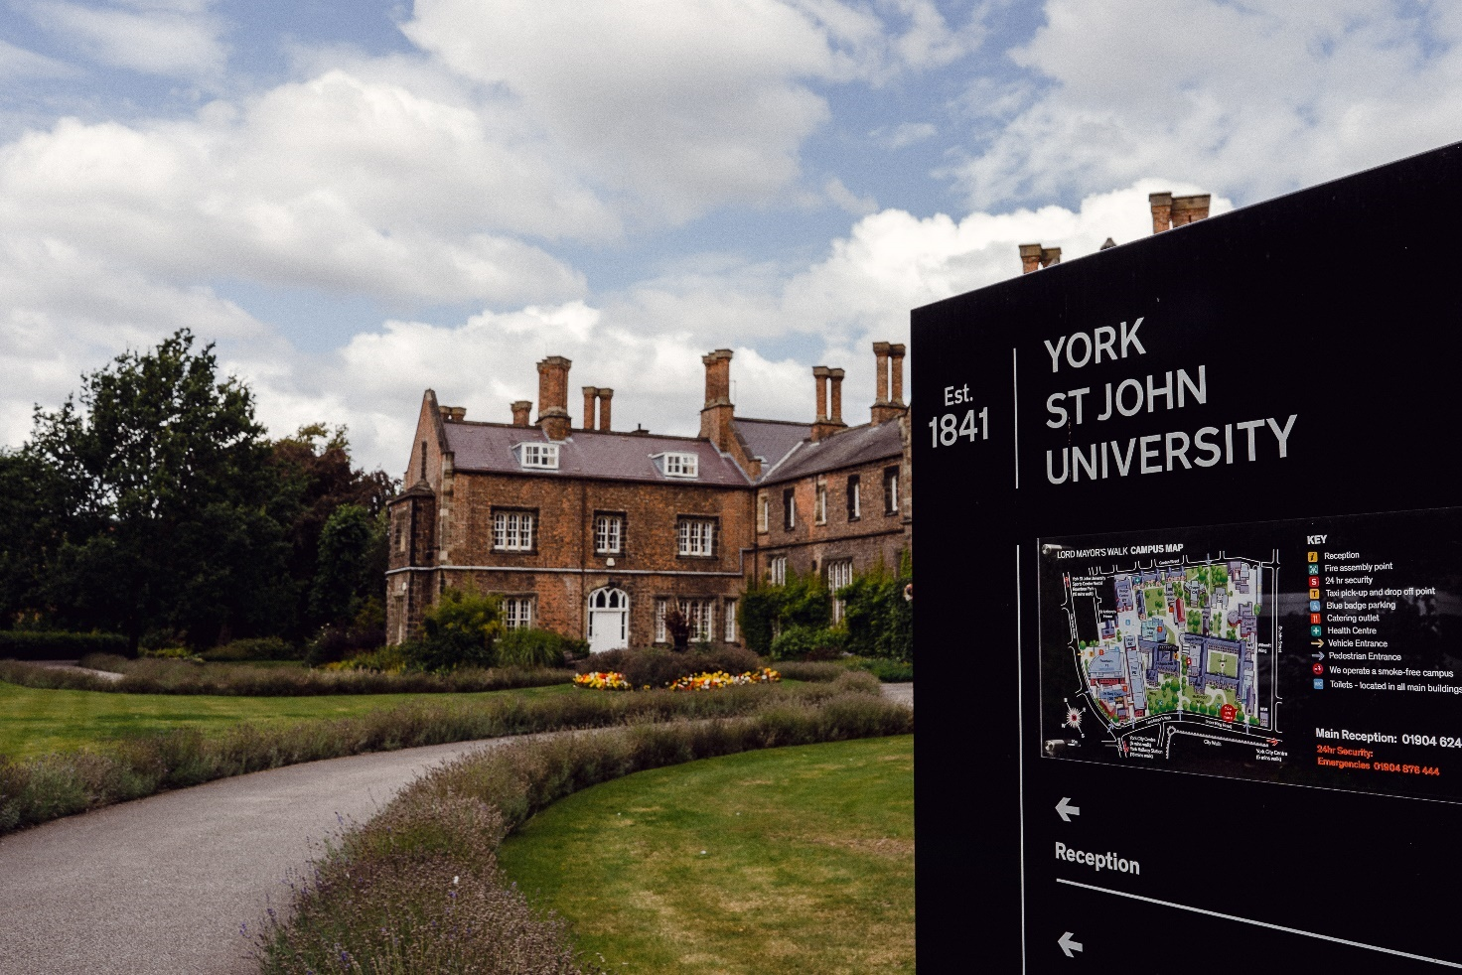
Introduction

The aim of this booklet is to give you, as an ECT, a clear picture of the support, resources and advice that is available to you in the first years of your teaching career. Our commitment to you as a professional does not end when you leave university; working with all our ECTs, their employing schools and local authorities, we will continue to support you in order to build a successful career in the teaching profession.
You will find information about the support we offer and the advantages of being York St John University alumni in this booklet along with details of further study if this is a path you choose to take.
We always value contact with our ECTs. We will be keeping in contact with you over the first few years of your career and strive for this to be a two-way process – let us know how you are doing and if there is any advice or support we can offer.
Our dedicated email address is ect@yorksj.ac.uk
You will find further information and a wealth of resources on our ECT webpages:
https://blog.yorksj.ac.uk/ite/early-career-teachers/
Good luck in your career & make sure you keep in touch.
With best wishes,
From all the ITE staff at York St John University

YSJ Supporting ECTs

Contents
- ECT Charter
- ECT Support
- Postgraduate Qualifications at YSJ
- Alumni Benefits
- YSJ Library
- Careers
- YSJ Events

- ECT Charter
At York St John University, we recognise, and celebrate, the fact that many of our schools have very robust, highly effective ECT induction programmes. Our aim is to complement the support being offered in the school, by the Local Authority and Teaching School Alliances and to be instrumental in creating highly-skilled, confident and resilient teachers of the future.
This charter sets out our guarantee for all our ECTs. It sets an agreement between the ECT and the university in which both have important roles.
Support for ECTs will be offered in a number of ways:
Personal and professional development through:
- Providing a programme of transition into the ECT induction period during the summer term before qualifying including the use of the Career Entry Development Profile (CEDP) and target setting for induction.
- Supporting trainees when seeking employment in their first teaching post in the form of careers inputs and mock interviews with local Head teachers and senior school staff.
- Monitoring and providing additional targeted support for any trainees who were graded as ‘requires improvement’ at the end of their final school experience through our Career Entry Support Programme (CESP)
- Providing up-to-date and accurate information to all employing schools to ensure that all ECTs are fully supported in their induction period
- Encouraging ECTs to access online materials and resources available on our ECT webpages. These resources are available to all our graduates, including those who have not secured a teaching post.
- Providing continued professional development including ECT conferences which are offered, where practical, in conjunction with our partnership schools
Continued communication with the university through:
- Email contact from the ECT Lead throughout ECT induction, including half termly bulletins and regular webinars.
- Seeking the views of ECTs, mentors and head teachers via surveys and/ or questionnaires.
- Providing a range of opportunities for the ‘ECT voice’ to be heard and acted upon.
- Liaising with schools employing our graduates to try to ensure a smooth transition for all into their ECT induction.
- Providing up-to-date information regarding YSJ conferences and training that may be beneficial to ECTs.
- A dedicated inbox (ect@yorksj.ac.uk ) allowing ECTs to seek any further advice or support they may need during the early stages of their teaching career and to make suggestions for any additions to the ECT webpage.

- ECT Support
We understand that your ECT induction period can be very demanding and that there may be times when a little extra support may be needed. We therefore have a dedicated ECT email address ect@yorksj.ac.uk if you need to contact the university. We also have an ECT website https://blog.yorksj.ac.uk/ite/early-career-teachers/ where you will find advice, information, resources and information on upcoming events.
We offer three strands of support depending upon your circumstances:
Strand 1 – Pre-teaching Support (for those seeking employment)
- On-going access to/ support from YSJ Careers
- Monthly careers drop in sessions in the autumn term, each with a different focus: general support; writing an application, attending interviews, considering supply work. These will be hosted by YSJ ITE staff, YSJ Careers & guest speakers
- Those who opt to join a peer support group (see strand 2) will be, where possible, placed with peers also seeking employment
- On-going suggestions for CPD/ making the most of any voluntary experience
Strand 2 – Core Support (for all ECTs)
- Webinars focussing on a range of topics, hosted by a range of speakers
- Half termly bulletins sent via email
- Peer support groups, led by a YSJ 'Professional Guide'. Monthly meetings on Teams
- Access to the YSJ ECT website which will be regularly updated
- Regular contact with ECT Lead via Twitter/ email
During the first term of your ECT induction, we will contact both you and your employing school via email to see how things are going. We will ensure that your school receives a copy of your Career Entry Development Profile (CEDP), a letter explaining your placement grading and an updated reference.
Strand 3 – Enhanced Support (for those in employment seeking more tailored support)
- Use of Career Entry Support Programme (CESP)
- Tailored support via phone/ email/ Teams as needed
- ECT Lead contact with employing school as needed

We would be grateful if you could keep us up-to-date with your employment details, please email any updates to the dedicated inbox.

- Postgraduate Qualifications at YSJ
YSJ graduates from ITE are encouraged to build on their qualification and consider further Master’s level study. Teachers can benefit professionally from engagement with research, gaining research skills in order to facilitate change within schools and make a difference for example to teaching and learning and leadership. There are personal benefits to be gained from collaborative learning and the opportunity to develop subject specific knowledge and an internationally recognised qualification which will enhance careers prospects. Below are details of our MA Education and Professional Doctorate in Education (EdD) programmes. If you wish to pursue a subject based Master’s degree please refer to YSJ’s website:
https://www.yorksj.ac.uk/study/postgraduate/
MA Education
The MA Education offers the opportunity to engage in critical debate about current policy issues and developments in education and to relate these to practice. The programme is ideal if you are currently working in the education sector wishing to develop the critical and analytic skills needed for more senior positions. It is also relevant if you are an early career teacher, retraining, returning to the education sector after a break or looking to develop research expertise in education. It is relevant to the wider education sector such as schools, museums, adult education, prisons, early years, mentoring and youth work, community education, educational research, and education policy. Recognising that we work in a global context, the theme of global, national local runs throughout the programme, encouraging you to explore the interconnected nature of education across the world and how global phenomena impact national and local policy and practice.

This is a two-year part time programme. If you have a recent PGCE, gained within the last five years, or both a PGCE and a recent national leadership qualification (NPQML, NPQSL, NPQHT), with the latter gained within the last five years, is it possible to apply for a fast-track route which leads to an MA after 16 months of part-time study. The FastTrack route, includes a module on critical approaches to education and a module on methods of inquiry followed by a dissertation.
The programme is delivered as blended learning, with all face-to-face taught content at weekends, allowing you to study flexibly around work commitments. It focusses on critical analysis, equipping you with the skills to problem solve and question established practice. A broad focus on local, national and global practice and policy is embedded throughout the programme, allowing you to evaluate a range of educational practices and policies. If you are taking the full programme, not the FastTrack, you have the opportunity to choose a specialist module on either evaluating inclusion or critical approaches to educational leadership according to your career plans. You will gain MA-level research skills and carry out an independent research project in the final Dissertation module.

Our academic team has expertise in social justice in education, especially regarding children, young people, student, staff and parent voices in education. We research critical pedagogies, risk, mental health and well-being, autism, governance, education policy and early childhood. Our staff draw on a range of research methodologies including participatory research, action research, democratic research, critical discourse analytics, and quantitative methodologies. Whilst we are academics in higher education we all have experience in education in a broad range of settings including adult education, schools, early years settings, informal and community education and we still work with educational settings through our research, professional work and in voluntary roles such as school governance.

https://www.yorksj.ac.uk/courses/postgraduate/children-young-people-and-education/education-ma/

Professional Doctorate in Education (EdD)
Our Professional Doctorate in Education (EdD) is internationally recognised as a flexible taught doctoral programme. We welcome applications from experienced educational practitioners and those in related fields (such as policy, leadership or support), who are committed to extending their understanding and improving practice.

Our programme will provide you with the skills and confidence to conduct your own original research. This will start with you identifying a problem of practice pertinent to you and your professional role, with a view to developing original solutions and disseminating professional knowledge to have real social and educational impact. You will also examine a range of educational and critical theories and explore conceptions of practice that influence not only your own professional pedagogy but also education more broadly.

Our EdD is a part-time programme and our students typically complete the course within 4 years, although you can extend your studies during the thesis stage if necessary. Teaching in the first 2 years of study takes place across two half-term weeks each year. In your remaining years of study, you will undertake and defend a doctoral thesis of 50,000 words in your chosen area of interest. If you want to find out more, you can visit our EdD programme page.

Completing a doctorate demonstrates your expertise in a particular area of education or practice and can enhance your career prospects. Evidence suggests that those with a postgraduate qualification will earn an average of £6,000 a year more than those with only an undergraduate degree (DfE, 2017).

As a postgraduate researcher on our EdD, you will become a valued part of our research community and will have opportunities to attend and contribute to various research events across the University, including the Education Doctoral Summer School.

Applications are open now for our next intake! If you would like to find out more about the course, speak with the Programme Lead or apply online.

4. Alumni Benefits
The York St John University experience continues long after you graduate. The Alumni Office will help you enjoy a lifelong relationship with York St John University and other alumni. There are also many benefits on offer if you return to YSJ or through links with local businesses.
https://www.yorksj.ac.uk/alumni/

5. YSJ Library
We offer all graduates alumni membership of the library for free.
Further information can be found here: https://www.yorksj.ac.uk/campus-and-facilities/library/membership/

6. Careers
YSJ graduates are offered lifelong careers guidance from the LaunchPad Careers team, including a range of support to help them to make the most of their unique skills and experiences.
The Careers team are able assist in many ways, including:
- Working out what ‘success’ means to you and what your next steps could be to achieve this.
- Effectively marketing yourself in CVs, job applications and interviews, including for further study.
- Individualised coaching and guidance during your search for employment and throughout your career.
- Access to LaunchPad Online to book Careers Guidance appointments, discover upcoming webinars and events, and search for work experience or job opportunities.

https://www.yorksj.ac.uk/careers-and-placements/

7. YSJ Events
You can find information of upcoming events at YSJ via the link below. We will also contact all ECTs about any events specifically aimed at those involved in teaching.
https://www.yorksj.ac.uk/events/

